😐 □            □□ 

😐 □       is the continuative use of the conjunction KAI, meaning “And,” followed by the genitive absolute construction, which includes the genitive masculine singular aorist active participle of the verb ERCHOMAI, which means “to come” and the genitive ‘subject of the participle’ from the third person masculine singular personal use of the intensive pronoun AUTOS, meaning “He.”
The aorist tense is a constative/historical aorist, which views the action in its entirety as a fact.
The active voice indicates that Jesus produced the action.
The participle is a temporal participle that precedes the action of the main verb and can be translated “after He came.”
Next we have the preposition EIS plus the accusative of place from the neuter singular article and adverb of place PERAN, meaning “to the opposite shore.” Then we have the preposition EIS plus the accusative of place from the feminine singular article and noun CHWRA with the genitive of identity from the masculine plural article and proper noun GADARĒNOS, meaning “into the district of the Gadarenes.”

“And after He came to the opposite shore into the district of the Gadarenes,”

 is the third person plural aorist active indicative from the verb HUPANTAW, which means “to meet.”
The aorist tense is a constative/historical aorist, which views the action in its entirety as a fact.
The active voice indicates that the two men produced the action.
The indicative mood is declarative for a simple statement of fact.
Next we have the dative direct object from the third person masculine singular personal use of the intensive pronoun AUTOS, meaning “Him.” Then we have the nominative subject from the masculine plural cardinal adjective DUO and the nominative masculine plural present deponent middle/passive participle of the verb DAIMONIZOMAI, which means “two demon-possessed men.” The participle is substantival; therefore, the morphology is not necessary. The word ‘men’ comes from the masculine plural ending. This is followed by the preposition EK plus the ablative of separation or ablative of origin from the neuter plural article and noun MNĒMEION, which means “out of the tombs.” Then we have the nominative masculine plural present deponent middle/passive participle of the verb EXERCHOMAI, which means “to come out.”
The present tense is a descriptive present of what was occurring at that moment.
The deponent middle/passive voice is middle/passive in form but active in meaning with the subject (the two men) producing the action.
The participle is a temporal participle that coincides with the action of the main verb and can be translated “while coming out.”

“two demon-possessed men met Him, while coming out of the tombs;”

       □□   is an ellipsis of the verb EIMI, meaning “[they were],” followed by the predicate nominative from the masculine plural adjective CHALEPOS and the adverb LIAN, meaning “exceedingly, highly, or very violent, dangerous.” Next we have the conjunction HWSTE, which introduces a result clause and means “with the result that.” This is followed by the negative adverb MĒ, meaning “not” plus the present active infinitive of the verb ISCHUW, which means “to be strong enough.”
The present tense is a descriptive present of the current situation.
The active voice indicates that anyone could not produce the action of being strong enough.
The infinitive is an infinitive of result.
Next we have the accusative ‘subject of the infinitive’ from the masculine singular indefinite pronoun TIS, meaning “anyone; someone.” The combination of the negative MĒ with the indefinite pronoun produces the subject “no one.” Then we have the aorist active infinitive from the verb PARERCHOMAI, which means “to pass by; to go by.”
The aorist tense is a constative/historical aorist, which views the action in its entirety as a fact.
The active voice indicates that no one could produce the action.
The infinitive is a complementary infinitive.
Finally, we have the preposition DIA plus the adverbial genitive of place from the feminine singular article and noun HODOS with the adjective EKEINOS, meaning “through that way.”

“[they were] very violent, with the result that no one was strong enough to pass by that way.”

Mt 8:28 corrected translation
“And after He came to the opposite shore into the district of the Gadarenes, two demon-possessed men met Him, while coming out of the tombs; [they were] very violent, with the result that no one was strong enough to pass by that way.”

Mk 5:1-3a, “And they came to the other side of the lake, into the district of the Gerasenes. And when He got out of the boat, immediately a man from the tombs with an unclean spirit met Him, who had his dwelling place among the tombs.”
Lk 8:26-27, “And they sailed into the district of the Gerasenes, which is opposite Galilee. Now when He stepped out on land, a certain man from the city met [Him], having demons; and for a long time he had not put on clothing; in addition he was not living in a house, but in the tombs.”

Explanation:

1. “And after He came to the opposite shore into the district of the Gadarenes,”
a. Matthew continues the story of the voyage of Jesus and the disciples from Capernaum by telling us that they came to the opposite shore on Lake Galilee, which was the district of the Gadarenes. Capernaum is on the north coast of the lake. The opposite shore would be the south shore. Most geographers/commentators insist that the district of the Gadarenes is on the eastern shore of the lake, some six miles away from Capernaum. However, the city of Garasa/Gadara and its surrounding district is in the south, some thirteen miles away from Capernaum.
b. Gadara was located east of the Jordan River on a mountain about 6 miles / 10 kilometers southeast of the Sea of Galilee. The people of Gadara were known as Gadarenes, although the general area was also known as the ‘country of the Gerasenes’ after the city of Gerasa which was about 45 miles / 73 kilometers farther south. See the maps at the end.

2. “while coming out of the tombs, two demon-possessed men met Him;”
a. Two demon-possessed men lived in the tombs (used for the burial of the dead) near the shore of the lake. They come out of the place where they live to attempt to meet Jesus and terrorize Him and those with Him. The demons think they can scare Jesus away as they have done with other men on many occasions.
b. The Greek order of the two clauses is the opposite of the proper English order. The proper English word is, “while coming out of the tombs, two demon-possessed men met Him.” The Greek order of the clauses is reversed. Typical Greek clause order is reversed by Matthew for the sake of emphasizing that these men were demon-possessed. Matthew does this so his readers will understand why these men were living in burial tombs.
c. Demon-possessed men lived in burial graves, because of the demon’s desire to be associated with death. Spiritual death wants to be associated with physical death. These demon-possessed men wanted nothing to do with the society of others. They wanted no contact with others, and living in burial tombs was the best way to do this.

3. “[they were] very violent, with the result that no one was strong enough to pass by that way.”
a. Matthew then tells us the major characteristic of these two demon-possessed men. They were very violent, which means that they physically attacked anyone who came near them. Note that they weren’t just violent, but very violent. They took great pleasure in beating people senseless. They wanted to hurt people and took great pleasure in doing so.
b. The implication of the next statement is that people living in the area had attempted to control them, but could not overpower them. Matthew tells us that no one was strong enough to do so. The implication is that the two demon-possessed men were given extraordinary strength by the demons to overpower all that came against them.
c. As a result of this extraordinary strength the demon-possessed men controlled travel from the lake to the city of Gadara in the south. Apparently people had to pass by the caves for the only route from the shore to the city beyond. Anyone who came that way was attacked by these two men. Thus Jesus and His disciples, including the men in the other boats are met by these two violent demon-possessed men, whose intent is to attack the whole group before them as they have done in the past and been successful.

4. Commentators’ comments.
a. “The name ‘Gadarenes’ comes from the town of Gadara, the capital of the region about eight miles southeast of the southern tip of the Sea of Galilee. Mark and Luke wrote that the place was ‘the region of the Gerasenes’ (Mk 5:1; Lk 8:26). There Jesus met … two demon-possessed men. Mark and Luke wrote of one demon-possessed man, but they did not say only one. Presumably one of the two was more violent than the other [or the leader of the two.] The influence of the demons on these men was obvious for they were wild, violent men, forced out of the city and living in a graveyard (tombs).”
b. “Gadara was a city of Decapolis, 6 miles (10 km) south-east of the lake, but controlling territory up to the shore of the lake east of the Jordan. In all three Synoptic Gospels there are variant readings. Mark and Luke probably wrote ‘Gerasenes’, perhaps referring to the modern Kursi, on the eastern shore, rather than to the Roman city of Gerasa, over 30 miles (50 km) from the lake. Gadarenes is probably Matthew’s original reading. There is no means of deciding whether the site of the incident was near the Jordan outflow (Matthew) or on the eastern shore (Mark/Luke). Both sites offer a ‘steep bank’ and both had largely Gentile populations, as the presence of a large herd of pigs requires. The ‘city’ of verse 33 need not be Gadara itself, but a local settlement near the lake within Gadarene territory. Matthew’s interest is in showing the authority of Jesus, and so he concentrates on His confrontation with the demons, not on the men who were the battleground; personal details are thus almost entirely omitted.”
c. “Demonization involves the indwelling of unseen evil spirits in a way that prevents an individual from fully controlling his or her own actions. Only Matthew speaks of two demoniacs, but he does not thereby contradict Mark and Luke. Perhaps one of the two dominated the conversation. But Matthew elsewhere includes two characters, where parallel accounts have one (9:27; 20:30); so he may be uniquely concerned to follow the principle of Dt 19:15, that a testimony be confirmed by two or three witnesses. The tombs (more properly ‘burial caves,’ epitomized uncleanness, forming an appropriate abode for the devils. Satan regularly dwells in that which is most profane. The violence of the demoniacs kept them from the rest of civilization. Mk 5:5 shows that their violence threatened themselves as well.”
d. “Matthew explains that this was the country of the Gadarenes. There is a problem in that Gadara was about six miles away from the lake and separated from it by a deep gorge. But Gerasa was about 40 miles away, so it is unlikely. The third reading, Gergesa, appears to have arisen because Origen suggested it (he does not cite earlier manuscripts for this reading). He argued that the other two readings arose only because Gergesa was a little town, not known to the scribes, who accordingly substituted the names of towns they knew in the region. There is some evidence that Gadara had territory on the shore of the lake, and our best understanding is that Matthew is right in referring to Gadara and that the territory ruled from this city extended to the lake. We lack information about the precise boundaries of the territories claimed by any of the cities in the region, but there is nothing improbable in the suggestion that the sovereignty of Gadara reached the lake and that there was a settlement there with a name that could be corrupted into ‘Gergesa’ and perhaps ‘Gerasa’, so that all three names entered the tradition. We should notice that Matthew does not say that they went to Gadara or Gerasa or Gergesa, but to ‘the country’ of whatever city is to be read. It was a predominantly Gentile region, as is shown by the reference to the herd of pigs, which would not be found in a Jewish area. The landing party encountered two demoniacs. This presents us with a problem, in that Mark and Luke speak of only one. It may be that one was more prominent than the other and that Mark and Luke concentrate on this man. In the end we must confess that we really do not know the reason for the difference. Matthew says that the two were coming out of the tombs. It is possible that some tombs had been abandoned (so Lenski). Matthew tells us that they were exceedingly violent. Thus the form their demon possession took made them a menace to society. The result was that no one was able to pass by. The fierceness of their attacks made it impossible for people to make ordinary use of that road.”
e. “The maps and the comments usually place the locality where Jesus landed too far north. Evidently, one of the two was the leader and spokesman, the other only his companion.”

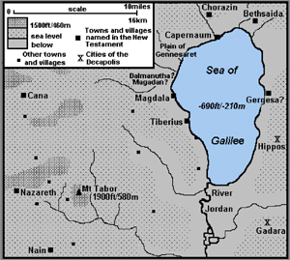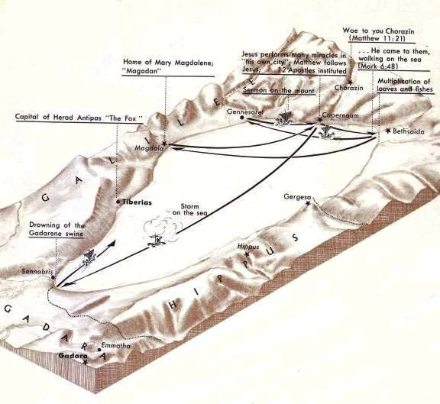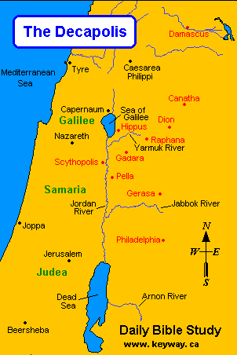

BDAG, p. 775.
Barbieri, L. A., Jr. (1985). Matthew. The Bible Knowledge Commentary: An Exposition of the Scriptures (Vol. 2, pp. 37–38). Wheaton, IL: Victor Books.
France, R. T. (1985). Matthew: an introduction and commentary (Vol. 1, pp. 166–168). Downers Grove, IL: InterVarsity Press.
Blomberg, C. (1992). Matthew (Vol. 22, p. 151). Nashville: Broadman & Holman Publishers.
Morris, L. (1992). The Gospel According to Matthew (pp. 208–209). Grand Rapids, MI; Leicester, England: W.B. Eerdmans; Inter-Varsity Press.
Lenski, p. 350.

