 □  

 □  is the continuative use of the conjunction KAI, meaning “And,” followed by the third person singular aorist active indicative from the verb APERCHOMAI, which means “to go: went.”
The aorist tense is a constative/historical aorist, which views the action in its entirety as a fact.
The active voice indicates that the news produced the action.
The indicative mood is declarative for a simple statement of fact.
Next we have the nominative subject from the feminine singular noun AKOĒ, meaning “the fame, report, rumor Mt 4:24; 14:1; 24:6; Mk 1:28; 13:7.” However, the translation “the news” is an excellent representation of the meaning of this word in the passive sense and is suggested by other lexicons. With this we have the adverbial genitive of reference from the third person masculine singular personal use of the intensive pronoun AUTOS, meaning “about Him” and referring to Jesus. Next we have the preposition EIS plus the accusative of place from the feminine singular adjective HOLOS plus the article and proper noun SURIA, meaning “into all Syria.”

“And the news about Him went into all Syria;”

  is the additive use of the conjunction KAI, meaning “and,” followed by the third person plural aorist active indicative from the verb PROSPHERW, which means “to bring to: they brought to.”
The aorist tense is a constative/historical aorist, which views the action in its entirety as a fact.
The active voice indicates that people produced the action.
The indicative mood is declarative for a simple statement of fact.
With this we have the dative indirect object from the third person masculine singular personal use of the intensive pronoun AUTOS, meaning “to Him” and referring to Jesus. Next we have the accusative direct object from the masculine plural adjective PAS plus the articular present active participle of the verb ECHW, which means “to have: having” and the adverb of manner or degree KAKWS, meaning “illness, sickness; sickly.” This construction (ECHW plus KAKWS) is an idiom, meaning “to be sick: were sick.”
The article functions as a relative pronoun, translated “who.”
The present tense is a historical present, which describes the past action as though occurring right now for the sake of vividness or liveliness in the narrative. It is translated by the English past tense.
The active voice indicates that people produced the action of being sick.
The participle is circumstantial.

“and they brought to Him all who were sick”

 is the instrumental of association from the feminine plural adjective POIKILOS, which means “with various” plus the noun NOSOS, meaning “diseases.” Then we have the conjunction KAI, used in a series of connectives like our use of commas. This is followed by the instrumental of association from the feminine plural noun BASANOS, which means “with severe pains.” Next we have the accusative direct object from the masculine plural present passive participle of the verb SUNECHW, which means “to be tormented; to be seized; to be attacked.”
The present tense is a descriptive present of what is now occurring.
The passive voice indicates that the person so afflicted receives the action.
The participle is circumstantial.
Then we have the appositional accusative masculine plural present deponent middle/passive participle of the verb DAIMONIZOMAI, which means “to be demonized; to be demon possessed.”
The present tense is a descriptive present of what is now occurring.
The deponent middle/passive voice is middle/passive in form but active in meaning with the subject (various people) producing the action.
The participle is substantival.
Next we have the accusative masculine plural present deponent middle/passive participle of the verb SELĒNIAZOMAI, which means “to be an epileptic.” The morphology is the same. This is followed by the accusative masculine plural from the adjective PARALUTIKOS, which means “paralytics.”

“with various diseases, being seized with severe pains, being demon possessed, epileptics, paralytics;”

 is the additive use of the conjunction KAI, meaning “and,” followed by the third person singular aorist active indicative from the verb THERAPEUW, which means “to heal: He healed.”
The aorist tense is a constative/historical aorist, which views the action in its entirety as a fact.
The active voice indicates that Jesus produced the action.
The indicative mood is declarative for a simple statement of fact.
Finally, we have the accusative direct object from the third person masculine plural personal use of the intensive pronoun AUTOS, meaning “them” and referring to the sick people.

“and He healed them.”

Mt 4:24 corrected translation
“And the news about Him went into all Syria; and they brought to Him all who were sick with various diseases, being seized with severe pains, being demon possessed, epileptics, paralytics; and He healed them.”

Explanation:

1. “And the news about Him went into all Syria;”
a. As a consequence of Jesus’ ministry of healing and teaching, the report, the news, the information about Him went throughout the entire Roman province of Syria. This is not a reference to the present day country of Syria, but the Roman province of Syria. The capital of the province was in Damascus and included all the territory from Egypt in the south to eastern Turkey in the north, the Mediterranean Sea in the west, and the Euphrates River valley in the east. This included all the districts mentioned in the next verse and more.
b. Matthew’s point is that Jesus was well known by report throughout all the area in which He ministered and beyond. He was not just famous in Galilee. For example, just as Billy Graham was not just well known in his home state; he was well known throughout the entire United States.
c. News at that time spread through word of mouth. We are not told what people actually said about Him as the news of His ministry spread, probably because there were so many different versions and stories of what people had seen Him do and heard Him say.
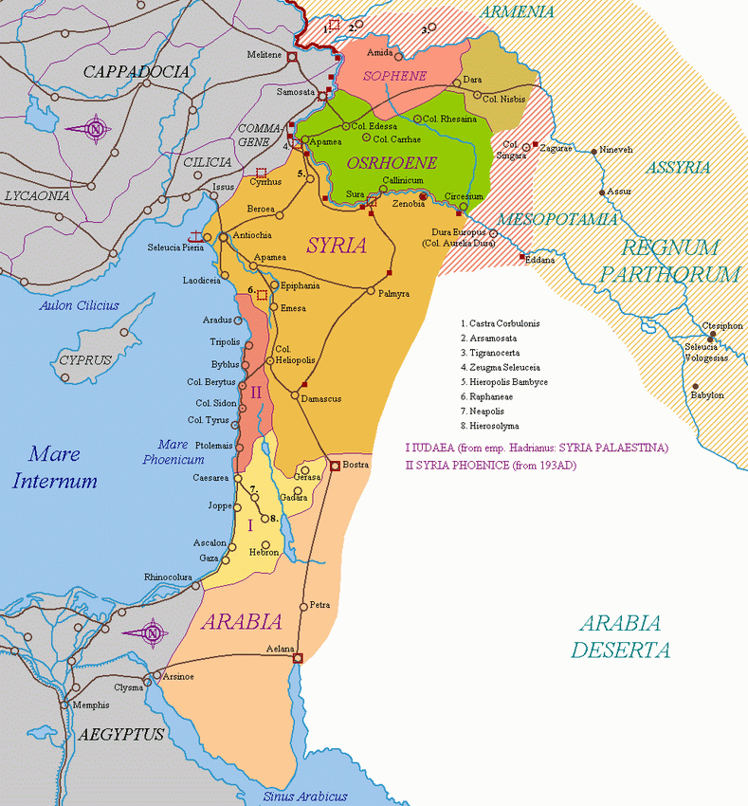

2. “and they brought to Him all who were sick”
a. The subject ‘they’ refers to primarily the Jews, but Jesus never turned any Gentile away that came to Him for healing. The subject refers specifically to the friends and relatives of the sick people. The sick were generally too ill to travel on their own, but had to be helped by others.
b. Jesus couldn’t get to all the sick people as fast as they could be brought to Him. This was not a matter of Him not wanting to go to them, but the expediency of them being brought to Him.
c. Jesus played no favorites. He was available to help anyone in need of His help that believed in Him. And it didn’t matter what the sickness was. Jesus helped any and everyone and cured everything regardless of the type of disease, sickness, illness, weakness, deformity, or malady.

3. “with various diseases, being seized with severe pains, being demon possessed, epileptics, paralytics;”
a. Matthew then elaborates on this point. It didn’t matter what the disease was; Jesus could heal them all. It didn’t matter what kind of pain a person was suffering with; Jesus could heal them all. It didn’t matter if the person was demon possessed or had a demon-induced illness; Jesus exorcised the demon(s). Jesus healed all forms of epilepsy and all forms of paralysis. There was nothing He could not and would not heal.
b. The Creator of man had (and has) the ability to correct any physical problem in His creation, including all genetic problems, viruses, bacteria, and anything we can imagine.
c. The mention of demon-possessed illnesses is significant, because this is a direct counterattack on Satan’s kingdom and policy of tormenting man through the creation of disease and illness. The fall of man created significant genetic problems for man, which led to all manner of diseases. Satan adds to the problem with his demon-induced illnesses. All demons are confined to the Hades prison for demons, called ‘the Abyss’, during the entire millennial reign of Jesus. There will be no demon possession or demon-induced illness during our Lord’s kingdom on earth.
d. Whoever came to Jesus with whatever type of physical problem they had were healed immediately and publically. No one in the history of the world has ever been able to do this but our Lord Jesus Christ. It is one of the greatest proofs that He is the Messiah, and no one could legitimately question His ability to do this. His enemies accused Him of being a fake, but thousands, if not millions of people saw what He did with their own eyes.

4. “and He healed them.”
a. Matthew then concludes this witness with a definitive statement that our Lord healed everyone who came to Him regardless of physical problem. Even though the word “all” is not added to the end of the statement, the implication is clear that this is what occurred.
b. Jesus’ desire, ability, and work of healing everyone who came to Him is a preview of coming attractions in His millennial reign. During our Lord’s thousand-year kingdom on earth there will be no disease, no deformity, no physical problems for anyone. There will be no germs, no viruses, no harmful bacteria, no genetic problems, and no physical weakness. Death and disease will take a holiday. During His first advent, our Lord was demonstrating this characteristic of His future kingdom by creating this condition in Galilee as evidence of what He will do worldwide in the future.
c. Jesus was demonstrating the physical perfection of His kingdom, but He was teaching about the spiritual perfection of His kingdom as well. This we will see in the next three chapters of Matthew’s story.

5. Commentators’ comments.
a. “As people came, they brought many who were afflicted with a variety of illnesses and Jesus healed them all.”
b. “Jesus’ ministry affected six political regions, an area of two hundred by one hundred miles; all this was achieved in a relatively short time without the aid of modern technology or transport!”
c. “While Jesus remained in Galilee, His reputation spread throughout all Syria (probably in the Old Testament sense meaning the regions neighboring Israel to the north and north-east, not the much larger Roman province of Syria [I disagree; Matthew knew exactly what the term Syria referred to at the time he wrote this and so did his audience]). The variety of healings specifically recorded in the Gospels amply justifies this list of various diseases. The exorcism of demoniacs, usually distinguished from physical healing, is here included as an aspect of the practical effect of the coming of the kingdom of heaven.”
d. “Matthew enumerates several categories of maladies that Jesus cures. Examples of all of these will subsequently be illustrated. The most striking on the list is demon possession, which Matthew carefully distinguishes from ordinary diseases, including epilepsy. Contrary to what many today believe, the ancient world regularly and carefully distinguished between afflictions ascribed to demons and other forms of illness. Demon possession was viewed as a unique situation in which an evil spirit actually took control of an individual, acting and speaking through that person in at least partial independence of his or her own volition and consciousness. Almost everyone in ancient societies believed in the reality of demon possession, and striking examples of it remain common enough today so as to be deniable only through severe naturalistic prejudice.”
e. “”What Jesus was doing could not remain unnoticed, and the report went out about Him. We would have expected that the report would go into all Galilee (and it probably did), but Matthew surprises us by mentioning Syria. He probably means that the news of what Jesus was doing spread very widely and went into the neighboring country as well as throughout the one in which Jesus was working. But Syria was the name of the Roman province that covered all Palestine (cf. Luke 2:2; Acts 15:23, 41), and He may be referring to the province. Either way the expression covers a wide area. Matthew does not supply a subject for his verb brought, but there is no difficulty in understanding that family or friends would perform this service. He refers to people who were ill, a general term covering all kinds of physical complaints, and he proceeds to elaborate on this. Diseases is the word used in the previous verse, after which Matthew goes on to those in the grip of torments. To these he adds demoniacs, a very important group in an age when so much was attributed to demon possession. All three Synoptic Gospels make a great deal of Jesus’ power over demons. Matthew goes on to lunatics (apparently different from the demoniacs); these are often held to be epileptics in modern discussions, and some of the cases may indeed be those of epilepsy. But we should bear in mind that the word is the exact etymological equivalent of ‘lunatic’ and that there is no reason for denying that meaning here. Matthew rounds off his list with paralytics, people for whom there was no cure in the first century. It meant a great deal to Matthew, as to the sufferers, that Jesus healed these people too.”
f. “These healings are acts of grace and mercy, performed as such, and thus they distinguish the character of Jesus as the Messiah and of the message He brought. These miracles still stand as the divine seals attesting the message to which they were appended. And this attestation, once made and forever fixed in a divinely inspired record needs no repetition, and therefore, has none.”

BDAG, p. 102, meaning 1.b.
Arndt, Danker, Bauer & Gingrich, (2000). A Greek-English Lexicon of the New Testament and other early Christian literature (3rd ed., p. 36). Chicago: University of Chicago Press.
BDAG, p. 886.
BDAG, p. 422, meaning 10.b.
BDAG, p. 168.
BDAG, p. 919.
Barbieri, L. A., Jr. (1985). Matthew. The Bible Knowledge Commentary: An Exposition of the Scriptures (Vol. 2, p. 28). Wheaton, IL: Victor Books.
Mills, M. S. (1999). The Life of Christ: A Study Guide to the Gospel Record (Mt 4:24–25). Dallas, TX: 3E Ministries.
France, R. T. (1985). Matthew: an introduction and commentary (Vol. 1, p. 110). Downers Grove, IL: InterVarsity Press.
Blomberg, C. (1992). Matthew (Vol. 22, p. 92). Nashville: Broadman & Holman Publishers.
Morris, L. (1992). The Gospel according to Matthew (pp. 89–90). Grand Rapids, MI; Leicester, England: W.B. Eerdmans; Inter-Varsity Press.
Lenski, p. 177.

