😐   □      □     ◻      

😐   □      □     is the continuative use of the conjunction KAI, meaning “And,” followed by the adverb of place EKEITHEN, meaning “from there.” With this we have the nominative masculine singular aorist active participle of the verb ANISTĒMI, which means “to get up; to stand up.”
The aorist tense is a constative/historical aorist, which views the entire past action as a fact.
The active voice indicates that Jesus produced the action.
The participle is a temporal participle that precedes the action of the main verb and can be translated “after getting up.”
Then we have the third person singular present deponent middle/passive indicative from the verb ERCHOMAI, which means “to come: He came.”
The present tense is a historical present, which describes the past action as though occurring right now for the sake of vividness or liveliness in the narrative. It is translated by the English past tense.
The deponent middle/passive voice is middle/passive in form but active in meaning with the subject (Jesus) producing the action.
The indicative mood is declarative for a simple statement of fact.
This is followed by the preposition EIS plus the accusative of place from the neuter plural article and noun HORION plus the genitive of identity (or possession or place) from the feminine singular article and proper noun IOUDAIA, meaning “into the regions of Judea.” Then we have the additive use of the conjunction KAI, meaning “and [the region],” followed by the preposition PERAN plus the adverbial genitive of place from the masculine singular article and proper noun IORDANĒS, meaning “beyond the Jordan.”

“And after getting up from there, He came into the regions of Judea and [the region] beyond the Jordan;”

 is the continuative use of the conjunction KAI, meaning “and,” followed by the third person plural present deponent middle/passive indicative from the verb SUMPOREUOMAI, which means “to gather with others in the same place: come together, flock Mk 10:1.”
The present tense is a historical present, which describes the past action as though occurring right now for the sake of vividness or liveliness in the narrative. It is translated by the English past tense.
The deponent middle/passive voice is middle/passive in form but active in meaning with the subject (the crowds) producing the action.
The indicative mood is declarative for a simple statement of fact.
Then we have the temporal adverb PALIN, meaning “again” plus the nominative subject from the masculine plural noun OCHLOS, meaning “crowds.” This is followed by the preposition PROS plus the accusative of place from the third person masculine singular personal use of the intensive pronoun AUTOS, meaning “to Him” and referring to Jesus.

“and crowds flocked to Him again,”

 ◻    is the additive use of the conjunction KAI, meaning “and,” followed by the comparative conjunction HWS, meaning “as.” Then we have the third person singular pluperfect active indicative from the verb EIWTHA, meaning “to maintain a custom or tradition: be accustomed Mt 27:15; Mk 10:1; Lk 4:16; Acts 17:2.”
The pluperfect tense is an intensive pluperfect, which emphasizes the continuing results of a past action. It is usually translated by the English past tense. “In Mk 10:1 Jesus was teaching the people as was His custom, not as had been His custom.”
The active voice indicates that Jesus produced the action.
The indicative mood is declarative for a simple statement of fact.
This is followed by the temporal use of the adverb PALIN, meaning “again.” Then we have the third person singular imperfect active indicative from the verb DIDASKW, which means “to teach.”
The imperfect tense is an ingressive imperfect, which describes entrance into or the beginning of a continuous, past action without reference to its conclusion.
The active voice indicates that Jesus produced the action.
The indicative mood is declarative for a simple statement of fact.
Finally, we have the accusative direct object from the third person masculine plural personal use of the intensive pronoun AUTOS, meaning “them” and referring to the crowds.

“and, as He was accustomed, He again proceeded to teach them.”

Mk 10:1 corrected translation
“And after getting up from there, He came into the regions of Judea and [the region] beyond the Jordan; and crowds flocked to Him again, and, as He was accustomed, He again proceeded to teach them.”

Explanation:

1. “And after getting up from there, He came into the regions of Judea and [the region] beyond the Jordan;”
a. Mark continues the story of the first advent of Jesus by telling us what happened after Jesus had the discussion with His disciples in the house in Capernaum (Mk 9:33) about who would be greater in the kingdom of God. At some point after this teaching (Mark doesn’t tell us how long: days, weeks, etc.), Jesus and the disciples depart from Galilee and go into the region of Judea and the district or region beyond the Jordan, which is a part of Perea. People from this district flocked to see Him at the beginning of His ministry according to Mk 3:7-8, “And then Jesus withdrew to the lake with His disciples; and a great crowd from Galilee followed; and from Judea, and from Jerusalem, and from Idumea, and on the other side of the Jordan, and the region around Tyre and Sidon, a large number [of people], hearing everything that He was doing, came to Him.”
b. “A great deal has intervened between the events at the close of Mark 9 and those in the beginning of Mark 10. For these events see Matt. 18, John 7 to 11, Luke 9:57 to 18:14 (one-third of Luke’s Gospel comes in here). It was a little over six months to the end at the close of Mark 9. It is just a few weeks now in Mark 10. Jesus has begun his last journey to Jerusalem going north through Samaria, Galilee, across the Jordan into Perea, and back into Judea near Jericho to go up with the passover pilgrims from Galilee.”
c. John describes this same event near the end of Jesus’ first advent in Jn 10:40-41a, “And then He went away again to the other side of the Jordan to the place where John was baptizing the first time, and He was staying there. And many came to Him…” The region or district beyond the Jordan is called Perea. See the map below. “Perea, through which Jesus occasionally travelled between Judaea and Galilee, stretched from the River Arnon (which flows into the middle of the Dead Sea) to Pella, about twenty-four kilometers south of the Sea of Galilee, with a width throughout of twenty to twenty-five kilometers. This is the territory the New Testament calls ‘the region beyond the Jordan’ (Mk 3:8; 10:1), in other words, Trans-Jordan. Like Galilee, it was ruled by Herod Antipas (Lk 3:1).”

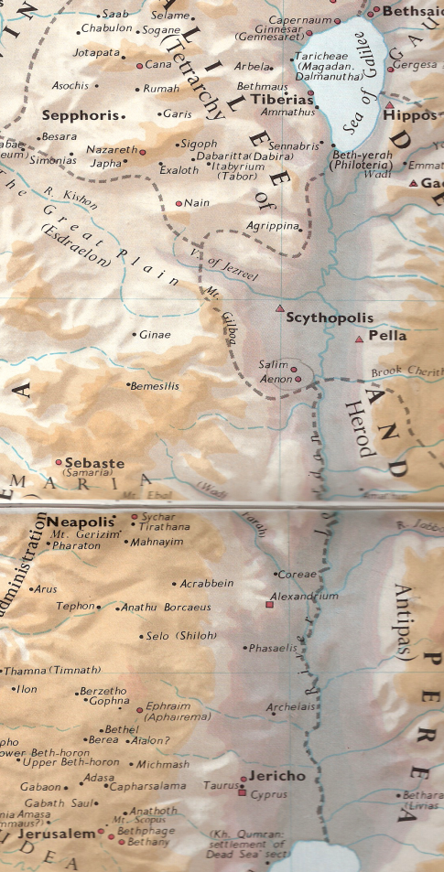

2. “and crowds flocked to Him again,”
a. Mark then tells us about the response of the crowds to hearing that Jesus was in the area again. They flocked to Him like sheep coming to their shepherd. This wording coincides with John’s mention of Jesus’ statement in Jn 10:11-14, “Jn 10:11, “I am the good shepherd; the good shepherd lays down His life for the sheep. The hired man, and not the one who is a shepherd, whose sheep are not his own, sees the wolf coming, and abandons the sheep and flees-and the wolf steals them and scatters-because he is a hired man and is not concerned about the sheep. I am the good shepherd, and I know My own and My own know Me,…”
b. The crowds were Jews from the district of Perea as well as from the district or region of Judea. The city of Jericho was very close and large numbers would come from there. This is the same place where John the Baptist had first ministered and where Jesus was also baptizing with John at the beginning of His public ministry. Jesus was no stranger to the area and the people here had always given Him a positive reception. It is from this area that Jesus will come to Bethany to heal Lazarus (Jn 11) just days before His triumphal entry into Jerusalem. Jn 10:40, “And then He went away again to the other side of the Jordan to the place where John was baptizing the first time, and He was staying there.”

3. “and, as He was accustomed, He again proceeded to teach them.”
a. Finally, Mark adds that Jesus did what He normally did with large crowds of people who were positive to His message—He proceeded to teach them. The content of what He taught is mentioned in Jn 10.
b. Jesus loved to teach others. We have no indication in the gospels that He ever got tired of teaching anyone. One of the titles that most characterize our Lord is “Teacher.” This teaching didn’t just happen that day, but continued during the final weeks and months He spent in this region from Festival of Lights in late December until the Passover at the beginning of April.
c. Included in all His teaching was the message of the gospel—that eternal salvation was being offered as a grace gift from God the Father to anyone who would believe that He, Jesus, would provide their eternal salvation from sinfulness. His message had always been that He was the Lamb of God who takes away the sins of the world.

Mt 19:1-2 is a parallel passage.

4. Commentators’ comments.
a. “This expression apparently means that Jesus left Galilee to go to Judea by way of Perea as the Galileans often did to avoid Samaria. Lk 17:11 expressly says that he passed through Samaria and Galilee when he left Ephraim in Northern Judea (Jn 11:54). He was not afraid to pass through the edge of Galilee and down the Jordan Valley in Perea on this last journey to Jerusalem.”
b. “Jesus completed His ministry in Galilee, left Capernaum, and came to the Trans-Jordan area, still on His way to the city of Jerusalem (Mark 10:32).”
c. “On Jesus’ final journey to Jerusalem, He left Capernaum in Galilee, and went into … Judea west of the Jordan River and then across the Jordan into Perea on the east side. Because of His popularity in these areas (Mk 3:8) He drew crowds of people around Him again and as was His custom He taught them again. Thus He resumed His public ministry. Though Jesus’ later Judean and Perean ministries covered a span of about six months, Mark recorded only some of the closing events which probably occurred in Perea (cf. Mk 10:2–52 with Lk 18:15–19:27).”
d. “Although Jesus had been absent from Judea for some time His fame preceded Him, and multitudes of the people resorted to Him, ready to hear what He had to say. According to His custom He took the opportunity to teach them.”
e. “Most teachers who taught in public did so in specific localities. Only figures popular with the masses drew such crowds as Jesus did wherever they went, and these popular teachers would naturally arouse the envy of many local professional scholars and the discomfort of the authorities.”
f. “This section conveniently locates the commencement of the last phase of Jesus’ ministry; beyond Jordan is Perea, the territory which fell under Herod’s [Antipas] jurisdiction in contrast to Judea which was under the procuratorship of Pilate. By leaving Judea, Jesus frustrated the Pharisees’ plans to arrest and execute Him as Perea was out of the area in which they could influence jurisdiction (the jurisdiction over religious matters conceded to the Sanhedrin only applied in Judea over which the Roman procurator ruled). In Perea, as in Galilee, Herod [Antipas] was the final authority and he jealously guarded his sovereignty; this is why the Pharisees on occasion were forced to resort to a distasteful alliance with the Herodians in the hopes of trapping Jesus.”
g. “With one statement Mark summarizes about six months of Christ’s ministry. His mention of Judea covers the later Judean period, recorded largely in Jn 7:10-10:39 and Lk 10:1-13:21; the reference to the farther side of Jordan has to do with the Perean ministry, the greater part of which is reported in Lk 13:22-19:28. The events of Mk 10:2-52 are in reality the closing events of this Perean period (compare Lk 18:15-19:28). There is an important textual problem here concerning the expression Judaea by the farther side of Jordan. The manuscript evidence favors the reading Judea and the farther side of Jordan. At first this appears to be an impossible text, since it seems to have reversed the natural order of Perea and Judea. Coming from Galilee, Jesus would have gone through Perea first, and then through Judea. However, this difficulty is removed by viewing 10:1 as a summary of the later Judean and the Perean periods of Christ’s ministry. Following the period of withdrawals, Jesus went first to Judea for three months; then he went to Perea for approximately the same length of time. Thus, the order in Mark’s summary—Judea first and then Perea—is correct.”
h. “From Capernaum Jesus came into southern Palestine. The order in which the provinces are listed (Judea and Perea) suggests that He went south across the mountains of Samaria into Judea, following the ordinary route for pilgrims on their way to the Holy City (Lk 9:51-53). At some point He crossed over the Jordan into Perea, which was part of the territory of Herod Antipas. In both Judea and Perea Jesus began teaching crowds of people once more, resuming a public ministry which had been discontinued some time before He left Galilee [Jn 6:66 tells us why].”
i. “A Galilean pilgrim to Jerusalem would commonly go down the east side of the Jordan, avoiding Samaria, and then cross to Jericho for the ascent to Jerusalem. But this verse does not easily fit that pattern. If KAI is read [part of the text], Judea and Perea are properly kept apart, but the order would then suggest going via Judea to Perea, the opposite of Jesus’ likely route.”

BDAG, p. 723.
Arndt, W., Danker, F. W., & Bauer, W. (2000). A Greek-English Lexicon of the New Testament and other early Christian literature (3rd ed.) (p. 959). Chicago: University of Chicago Press.
BDAG, p. 1104.
Arndt, W., Danker, F. W., & Bauer, W. (2000). A Greek-English Lexicon of the New Testament and other early Christian literature (3rd ed.) (p. 295). Chicago: University of Chicago Press.
Young, R. A. (1994). Intermediate New Testament Greek: A linguistic and exegetical approach (p. 130). Nashville, TN: Broadman & Holman.
Robertson, A. (1933). Word Pictures in the New Testament (Mk 10:1). Nashville, TN: Broadman Press.
du Plessis, I. (1998). Getting to know the geography, topography and archaeology of the Bible Lands in New Testament times. In A. du Toit (Ed.), Volume 2: The New Testament Milieu (A. du Toit, Ed.). Guide to the New Testament. Halfway House: Orion Publishers.
Robertson, A. (1933). Word Pictures in the New Testament (Mt 19:1). Nashville, TN: Broadman Press.
Wiersbe, W. W. (1996). The Bible Exposition Commentary (Mk 10:1). Wheaton, IL: Victor Books.
Grassmick, J. D. (1985). Mark. In J. F. Walvoord & R. B. Zuck (Eds.), The Bible Knowledge Commentary: An Exposition of the Scriptures (Mk 10:1). Wheaton, IL: Victor Books.
Ironside, H. A. (1948). Expository Notes on the Gospel of Mark. (p. 149). Neptune, NJ: Loizeaux Brothers.
Keener, C. S. (1993). The IVP Bible Background Commentary: New Testament (Mk 10:1). Downers Grove, IL: InterVarsity Press.
Mills, M. S. (1999). The Life of Christ: A Study Guide to the Gospel Record (Mt 19:1–Jn 10:42). Dallas, TX: 3E Ministries.
The Wycliffe Bible Commentary: New Testament. 1962 (C. F. Pfeiffer & E. F. Harrison, Ed.). Chicago: Moody Press.
Lane, p. 352f.
France, p. 389.

