 □

 is the continuative use of the conjunction KAI, meaning “And,” followed by the third person singular aorist active indicative from the verb EXERCHOMAI, which means “to go out.” It does not mean ‘to spread’ as found in the NASB.
The aorist tense is a constative/historical aorist, which views the action in its entirety as a fact.
The active voice indicates that the news about Jesus produced the action.
The indicative mood is declarative for a simple statement of fact.
Then we have the nominative subject from the feminine singular article and noun AKOĒ, meaning “the fame, report, account, message Mt 4:24; 14:1; 24:6; Mk 1:28; 13:7.” With this we have the possessive genitive from the third person masculine singular personal use of the intensive pronoun AUTOS, meaning “His” and referring to Jesus. This is followed by the temporal adverb EUTHUS, meaning “immediately.” Then we have the adverb of place PANTACHOU, meaning “everywhere; or in all directions.”

“And His fame went out immediately everywhere”

 □  is the preposition EIS plus the accusative of place from the feminine singular adjective HOLOS plus the article and adjective PERICHWROS, meaning “into all the region around, neighborhood Mk 1:28, the region around Galilee.” With this we have the genitive of identity from the feminine singular article and proper noun GALILAIA, meaning “of Galilee.”

“into all the region of Galilee.”

Mk 1:28 corrected translation
“And His fame went out immediately everywhere into all the region of Galilee.”

Explanation:

1. “And His fame went out immediately everywhere”
a. Mark continues by telling us the immediate result of what happened that morning. When the people left the synagogue and returned to their homes, farms, and villages outside the city of Capernaum, what Jesus said and did spread everywhere or in all directions.
b. The noun AKOĒ means “fame, report, account, or message.” People reported what they heard and saw. The account of what happened went out everywhere, and Jesus was immediately famous.
c. The news of what Jesus said and did did not just spread throughout the city of Capernaum, but spread to the villages outside the city and to other nearby cities (like Bethsaida of Galilee and Chorazin and Ginnesar aka Gennesaret). The word “immediately” tells us that the news spread like wildfire—it was fast and furious.

2. “into all the region of Galilee.”
a. From the villages and cities near Capernaum word traveled into all the region of Galilee. This would have taken no more than a few days to cover the entire area. The major cities where the news about Jesus would travel would be Nain and Nazareth in the South, Cana in the West, Chorazin in the North and the capital of Galilee—Tiberias in the East on lake Galilee. The other ‘cities’ are small towns and villages.
b. See the map below for the “region of Galilee.” The distance East to West on the map is about 20 miles. The distance North to South on the map is about 35 miles. From Capernaum, the news about Jesus healing a demon possessed man could reach any part of the region of Galilee within a day’s walk.

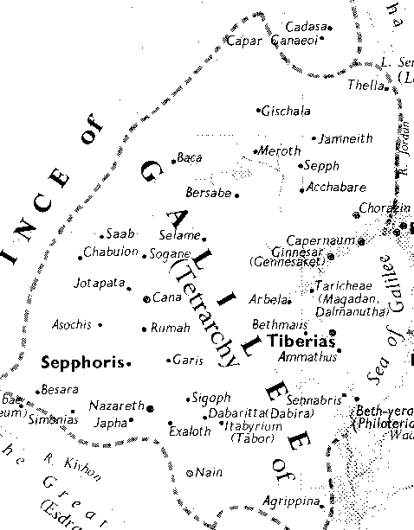

3. Commentators’ comments.
a. “They had no telephones, telegraphs, newspapers or radio, but news has a marvelous way of spreading by word of mouth. The fame of this new teacher went out ‘everywhere’ throughout all Galilee.”
b. “The report concerning the new Teacher spread with lightning speed by word of mouth.”
c. “The people kept on talking about both, and the fame of Jesus began to spread. Our Lord did not encourage this kind of public excitement lest it create problems with both the Jews and the Romans. The Jews would want to follow Him only because of His power to heal them, and the Romans would think He was a Jewish insurrectionist trying to overthrow the government. This explains why Jesus so often told people to keep quiet (Mk 1:44; 3:12; 5:43; 7:36–37; 8:26, 30; 9:9). The fact that they did not obey created problems for Him.”
d. “Galilee’s villages were close together, and close connections among them would allow word to spread rapidly.”
e. “The significance of this miracle did not escape the spectators (Mark v. 27), and word of Jesus’ astonishing power spread rapidly.”

BDAG, p. 348.
Arndt, W., Danker, F. W., & Bauer, W. (2000). A Greek-English Lexicon of the New Testament and other early Christian literature (3rd ed.) (p. 36). Chicago: University of Chicago Press.
BDAG, p. 754.
Arndt, W., Danker, F. W., & Bauer, W. (2000). A Greek-English Lexicon of the New Testament and other early Christian literature (3rd ed.) (p. 808). Chicago: University of Chicago Press.
Robertson, A. (1997). Word Pictures in the New Testament (Mk 1:28). Oak Harbor: Logos Research Systems.
Wuest, K. S. (1997). Wuest’s Word Studies from the Greek New Testament: For the English Reader (Mk 1:28). Grand Rapids: Eerdmans.
Wiersbe, W. W. (1996). The Bible Exposition Commentary (Mk 1:12). Wheaton, Ill.: Victor Books.
Keener, C. S., & InterVarsity Press. (1993). The IVP Bible Background Commentary: New Testament (Mk 1:28). Downers Grove, Ill.: InterVarsity Press.
Mills, M. (1999). The Life of Christ: A Study Guide to the Gospel Record (Mk 1:21–Lk 4:37). Dallas, TX: 3E Ministries.

