  □  □

  is the transitional use of the postpositive conjunction DE, meaning “Now” plus the nominative feminine singular aorist active participle of the verb ANISTĒMI, which means “to rise; set out; get ready.”
The aorist tense is a constative/historical aorist, which views the action in its entirety as a fact.
The active voice indicates that produced the action.
The participle is a temporal participle that precedes the action of the main verb and can be translated “after getting ready.”
Then we have the nominative subject from the feminine singular proper noun MARIA, meaning “Mary.” This is followed by the preposition EN plus the locative of time from the feminine plural article and noun HĒMERA with the demonstrative pronoun HOUTOS, meaning “in those days,” which is idiomatic, meaning “at that time Mt 3:1; 24:19, 38; Mk 1:9; Lk 2:1; 4:2b; 5:35b; at this time Lk 1:39; 6:12; Acts 1:15.”

“Now at this time Mary, after getting ready,”

 □  □  is the third person singular aorist deponent passive indicative from the verb POREUOMAI, which means “to go; to journey, travel; proceed.”
The aorist tense is a constative/historical aorist, which views the action in its entirety as a fact.
The deponent passive voice is passive in form but active in meaning with Mary producing the action.
The indicative mood is declarative for a simple statement of fact.
This is followed by the preposition EIS plus the accusative of place from the feminine singular article adjective OREINOS, meaning “to the hill country.” Then we have the preposition META plus the genitive of attendant circumstances from the feminine singular noun SPOUDĒS, “with haste.” Finally, we have the preposition EIS plus the accusative of place from the feminine singular noun POLIS and possessive genitive or genitive of identity from the masculine singular proper noun IOUDAS, meaning “to a city of Judah.”

“traveled with haste to the hill country, to a city of Judah,”

Lk 1:39 corrected translation
“Now at this time Mary, after getting ready, traveled with haste to the hill country, to a city of Judah,”

Explanation:

1. “Now at this time Mary, after getting ready,”
a. Luke moves the story of Elizabeth and Mary along by telling us what Mary did in the next few days after Gabriel appeared to Mary. The phrase “at this time” indicates the period of time after Gabriel departed and before Mary left to visit Elizabeth. Mary made up her mind that she was going to go visit her relative Elizabeth. Probably at some point during these next few days the Holy Spirit came upon Mary and the miraculous conception took place.
b. The phrase “after getting ready” implies and suggests several things:
(1) Mary probably told Joseph about the conversation with Gabriel. Joseph wasn’t going to just let Mary travel to southern Judea from Galilee and be gone for several months without knowing how Mary knew Elizabeth was pregnant and why she felt she needed to go help her at the end of her pregnancy.
(2) Mary had to let her family knew where she was going and why, so they wouldn’t think that she was deserting Joseph or that he had determined to divorce her. She was probably still living at home, since the marriage had not yet been consummated.
(3) She had to pack and find a group of people to travel with, since it was too dangerous to travel alone. Remember that she intended to be gone for several months. She wasn’t packing for an overnight visit.

2. “traveled with haste to the hill country, to a city of Judah,”
a. Luke then emphasizes her haste in leaving Nazareth and getting to southern Judea. The phrase “traveled with haste” indicates that she didn’t take her time, but went as fast as she could. Walking at 2.5 miles per hour for 8 hours (with periods of rest along the way each day) she could cover 20 miles per day without great difficulty.
b. The hill country of Judah is south of Jerusalem and suggests that she went to the city of Hebron. See the map below. The distance from Nazareth to Hebron is about 100 miles. So she had a brisk five-day walk.
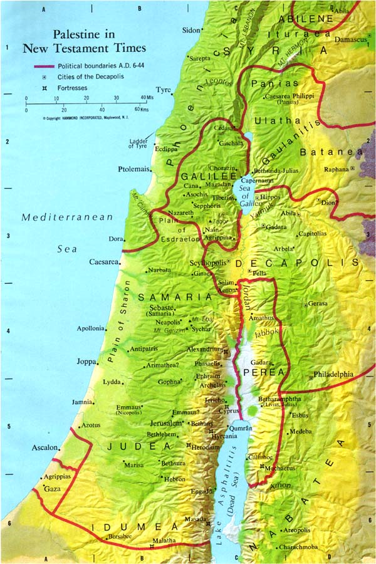

3. Commentators’ comments.
a. “The Virgin Mary’s departing ‘with alacrity’ means not only ‘hastily’ but ‘with fervor.’”
b. “The name of the city where Zacharias lived is not given unless Judah here means Juttah (Josh 15:55). Hebron was the chief city of this part of Judea.”
c. “Mary goes immediately to her relative’s side. She had been told of Elizabeth’s condition and now travels to see God’s sign. Her journey is made with haste into the Judean hill country, to a city south of Jerusalem. The journey, covering 80–100 miles, would take three or four days. Several reasons for this hasty journey have been posited. The context suggests that Mary’s haste reflects her obedience. Mary’s departure reflects an instant response to God’s leading. The city’s location within Judah is unknown. The reference is very indefinite. The exact location of the city is still a mystery. Luke’s point is simply that Mary goes to greet Elizabeth.”
d. “As a young girl, Mary would not normally have left her home without accompaniment—either to browse in her own hometown or (especially!) to travel some seventy miles to the hill country around Jerusalem. Until she entered the bridal chamber, a girl lived in seclusion in her home. Moreover, Mary’s journey is apparently unmotivated. [That’s a ridiculous comment.] She does not go in obedience to the angel [technically the angel didn’t command her, but the mere fact of mentioning Elizabeth’s condition was hint enough of what Mary should do], who gave her no such instructions. Nor does Luke include a report of Mary’s conception (though it is assumed in what follows). This lack of detail highlights the orientation of this narrative segment on her action, accented further by her ‘haste’.”
e. “The journey from Nazareth to the hill country of Judea may have taken three to five days, depending on the precise location of Elizabeth’s home. In view of bandits on the roads, young Mary’s journey was courageous, although she may have found a caravan with which to travel; otherwise her family may not have allowed her to go.”
f. “Mary was excited about the prospect of becoming the Messiah’s mother and wasted no time in going to Elizabeth to confirm the angel’s promise. We can understand her hasty departure from Nazareth, for the young maiden must have longed to discuss her incredible news with someone, and Elizabeth was the only one likely to believe her. But how did she arrange to leave her home and her betrothed? I suspect she disclosed that she had seen an angel in a vision who had revealed that her cousin Elizabeth was pregnant. She convinced her parents and Joseph of this, and persuaded them that she should nurse the aged Elizabeth through her pregnancy. Maybe, she hinted that there was more to her vision which she would disclose on her return! Elizabeth’s pregnancy was a secret; Elizabeth was in her sixth month before Mary left home; then we need to allow for a brief delay before Mary left and a week’s journeying time; so John’s birth was about three months away when Mary arrived at Elizabeth’s home. Third, Mary stayed with Elizabeth ‘about three months’ (verse 56). Mary would surely want to wait for the birth of Elizabeth’s son as positive confirmation that she had indeed seen a vision before she confronted her parents with her claim to be a pregnant virgin (the young lady would naturally be very anxious to convince her parents and her betrothed of her virtue). Her commitment to Elizabeth, and her commission from her parents, would in all probability have been to see Elizabeth through her pregnancy. It would be unnatural for a young girl to nurse a relative through the last three months of her pregnancy and then leave just before the babe was born. And finally, the bond of their shared secret, their common spiritual interest in the two infants they were carrying makes it unthinkable that Mary’s spiritual curiosity would not keep her with Elizabeth until her baby had been born. Mary’s journey was a considerable undertaking, for she traveled from Nazareth to the hill country south of Jerusalem. Her route would probably have been down the Jordan Valley to Jericho, then up the steep ascent to Jerusalem (4,000’ in fifteen miles), then past Bethlehem to the hill country—all told, a distance of one hundred and twenty miles on foot. Mary’s household was poor as she herself said (Lk 1:48). This must have been an exciting journey for the young maiden, with the thrill of each day’s fresh discoveries added to the unique secret locked in her womb. We know nothing of the incidents of that journey; we do know that Mary was destined to repeat all but fifteen miles of it less than nine months later.”
g. “Many [commentators] are willing to accept the traveler Reland’s conjecture that Juttah is meant (Josh 15:55; 21:16), which was about 8 miles south of Hebron.”
h. As the projected journey was one of several days, it would require time to arrange it and find an escort [for Mary]. Luke does not give the name [of the city], probably because he did not know it. It may have been Hebron, just as it may have been any town in the mountainous part of Judah, and Hebron was chief among the cities allotted to the priests. But if Luke had meant Hebron, he would have named it.”
i. “In obedience to the implicit command from Gabriel Mary goes to visit Elizabeth and stays until the birth of her child, thus seeing the fulfillment of the promised sign. From Lk 1:56f, it follows that Mary went to Elizabeth directly after the annunciation and before her marriage to Joseph. Mary’s haste reflects her obedience to the angelic message.”

BDAG, p. 83, meaning 10.
Arndt, W., Danker, F. W., & Bauer, W. (2000). A Greek-English Lexicon of the New Testament and other early Christian literature. Chicago: University of Chicago Press. Page 438.
BDAG, p. 721.
BDAG, p. 939.
Spicq, C., & Ernest, J. D. (1994). Theological Lexicon of the New Testament. Peabody, MA: Hendrickson Publishers. Volume 3, p. 277.
Robertson, A. T. (1933). Word Pictures in the New Testament (Lk 1:39). Nashville, TN: Broadman Press.
Bock, D. L. (1994). Luke: 1:1–9:50 (Vol. 1, pp. 133–134). Grand Rapids, MI: Baker Academic.
Green, J. B. (1997). The Gospel of Luke (pp. 94–95). Grand Rapids, MI: Wm. B. Eerdmans Publishing Co.
Keener, C. S. (1993). The IVP Bible Background Commentary: New Testament (Lk 1:39–40). Downers Grove, IL: InterVarsity Press.
Mills, M. S. (1999). The Life of Christ: A Study Guide to the Gospel Record (Lk 1:39–45). Dallas, TX: 3E Ministries.
Lenski, p. 77.
Plummer, 28.
Marshall, p. 77-80.

