  

    is the transitional use of the postpositive conjunction DE, meaning “Now” plus the third person singular imperfect active indicative from the verb EIMI, which means “to be: was.”
The imperfect tense is an aoristic/descriptive imperfect, which describes the past state of being as a fact.
The active voice indicates that the festival of the Jews produced the action.
The indicative mood is declarative for a simple statement of fact and reality.
Then we have the adverb of time EGGUS, which means “near.” This is followed by the nominative subject from the feminine singular article and noun HEORTĒ, which means “festival or celebration.” With this we have the possessive genitive from masculine plural article and adjective IOUDAIOS, meaning “of the Jews.”

“Now the festival of the Jews…was near.”

  is the appositional nominative subject from the feminine singular article and noun SKĒNOPĒGIA, which means “the Feast of Booths or Tabernacles.”

“the Feast of Tabernacles,”

Jn 7:2 corrected translation
“Now the festival of the Jews, the Feast of Tabernacles, was near.”

Explanation:

1. “Now the festival of the Jews, the Feast of Tabernacles,”
a. John continues in his description of the life of Jesus by moving us along six months. In Jn 6:4 John told us “Now the Passover, the festival of the Jews, was near.” Now he tells us that the festival of the Jews called the Feast of Tabernacles is near. Passover was celebrated in the middle of the month of Nisan (the 14th of Nisan, the month beginning in mid March and continuing until mid April). The Feast of Tabernacles was celebrated in the month of Tishri, which went from mid September to mid October. (See the chart at the end of these notes.)
b. “This festival, known variously as the Feast of Booths, (Lev 23:34; Dt 16:13), Tabernacles (2 Chr 8:13; Jn 7:2), or Ingathering (Ex 34:22), was one of the three major feasts in which all Hebrew males were required to participate each year. It began on the fifteenth day of the seventh month (Tishri), i.e., mid-October, five days after the Day of Atonement (Tishri 10). It continued for one week, and was associated with the end of the year (Ex 34:22) when agricultural work concluded. It was a ‘pilgrim’ festival, the intent of which was to emphasize the nomadic character of the wilderness period (Lev 23:43). On the first day the congregation ceased from all normal activities and presented burnt offerings to the Lord, a procedure that was repeated on the eighth day, after the festival proper had terminated. Lev 23:39–43 describes the ritual procedures that the Israelites were commanded to observe, and that gave the occasion its particular designation. The booths, which were simple shelters made of interlaced branches, were the people’s living quarters during the festival. In each seventh year occurred a special ceremony, a public recitation of the covenant provisions agreed to on Mt. Sinai by the Israelites in time of Moses. This served the extremely important function of keeping at the forefront of the people’s minds the obligations assumed on that occasion, as well as reminding them of the blessings that would follow as long as the provisions of the covenant were honored. The feast was celebrated against a background of rejoicing for divine blessings, represented by the bounty of the year’s harvest. This was reflected in its occasional designation as the ‘Feast of Ingathering’ (Ex 23:16; 34:22). The feast seems to have lapsed during the monarchy, so that the observance which occurred in Jerusalem during the time of Ezra was of particular significance. On that occasion a celebration of a character unknown since the time of Joshua took place (Neh 8:13–18). The popularity of the feast was maintained throughout the postexilic period, and it became the occasion on which Jews from the eastern Diaspora visited Jerusalem for worship and celebration. In at least one instance Christ Himself was in the city when the festival was being observed (Jn 7:2). By NT times it had become a custom on that feast for a procession to visit the Pool of Siloam and return with water, which was then poured out as a libation of thanksgiving to God. It may well have been as a result of witnessing this ceremony that Jesus was prompted to make His observations about living water and eternal life (Jn 7:37–39).”
c. “The final and greatest feast of the Israelite agricultural year, one of three annual pilgrimage festivals (Ex 23:14–19; 34:22–24; Lev 23:33–36, 39–43; Num 29:12–38; Dt 16:16–17; 31:9–13). It specifically celebrated the harvest of grapes and olives and the end of the harvest season in general. The Feast of Tabernacles (or Booths) is called Sukkot(h) (or Succoth) in Hebrew (2 Chr 8:13). The OT also refers to it as the Festival of Ingathering (Ex 23:16; 34:22), the Feast of the Lord (Lev 23:39, 41), or the ‘appointed feast’ (Lam 2:6, 7; Hos 12:9) or even simply ‘the feast’ (1 Kg 8:2, 65; 12:32). Tabernacles shared a number of elements with other vintage feasts of the region. The Greeks and Romans of the 1st century A.D. saw similarities to their own feast for Dionysus/Bacchus. The Feast of Tabernacles was to be held after the harvest (Dt 16:13; Lev. 23:39), on the 15th through the 22nd of Nissan, the seventh month (Sept.-Oct.; Lev 23:34; Num 29:12–38). It followed two other celebrations, the New Year (1st of Nissan) and the Day of Atonement (10th of Nissan). The Feast of Tabernacles was a time of celebration. The seven-day feast began and ended with a special sabbath. The work of harvest completed, the people were to rest, rejoice (Lev 23:39–40), and to eat and drink (cf. Dt 14:22–26, a tithe of their annual crops). Celebrants were to construct temporary shelters, the ‘tabernacles’ or ‘booths,’ in which to eat and sleep during the feast (Neh 8:14–17), reminding them of Yahweh’s protection during the wilderness wanderings (Lev 23:42, 43). The priests offered special sacrifices, including a unique one of a descending number of bulls each day (beginning with 13 the first day and concluding with seven the final day, a total of 71) (Num 29:13–38). Every seventh year during Tabernacles the entire Law was to be read (Dt 31:10–11). Postexilic observances included the lighting of giant menorahs in the temple courtyard, all-night dancing to flutes by torchlight, dawn processions ending with libations of water and wine at the bronze altar, prayers for rain and resurrection of the dead, the priests marching around the altar and the people carrying fruit and waving palm branches. When the high priest Alexander Jannaeus (about 100 B.C.) refused to offer the libations properly, troops called to quell the ensuing riot left 6000 people dead. Tabernacles came to be tied to Jewish hopes for a Davidic messiah and national independence. Judas Maccabees used the feast as a model for his celebration of the rededication of the Jerusalem altar in 164 B.C. (1 Macc 4:54–59), the first celebration of Hannukah (2 Macc 1:1–36).”
d. “City dwellers built their booths on the roofs of their houses, and in the streets and squares (Neh 8:14–17). According to the first-century Jewish historian Josephus, the Feast of Tabernacles was the most popular of the three major Jewish feasts. It was marked by celebrations and parties, and featured water-drawing and lamp-lighting rites (cf. Jn 7:37–38; 8:12). In the millennial kingdom, the Feast of Tabernacles will again be celebrated, in honor of Messiah’s dwelling with His people, and the ingathering of the nations into His kingdom (Zech 14:16–19).” “Women and children were not required to live in the booths.”
e. “A libation which was made every morning in the temple, recalled to mind the waters which Moses had caused to spring forth from the rock. Two candelabra, lighted at evening in the court, represented the luminous cloud which had given light to the Israelites during the nights. Josephus calls this feast the most sacred and greatest of the Israelite festivals. It was the last of the great legal feasts of the year; as Jesus had not gone, this year, either to the Passover-feast or to that of Pentecost, it might be presumed that He would go to this feast. For it was assumed that everyone would celebrate at least one of these three principal feasts at Jerusalem. Hence the ‘therefore’ of the following verse.”

2. “was near.”
a. John tells us that the feast of Tabernacles was near, which means that it was probably within a week of beginning.
b. Since Jesus tells His brothers to go to the feast, it was certainly less than two weeks away and probably even closer. We have no way of knowing for certain. However, what this does tell us is that the festival was so close that if a person was going to go, they had to begin their journey. Since this feast was one of the three major feasts each year, Jesus was expected to be there.

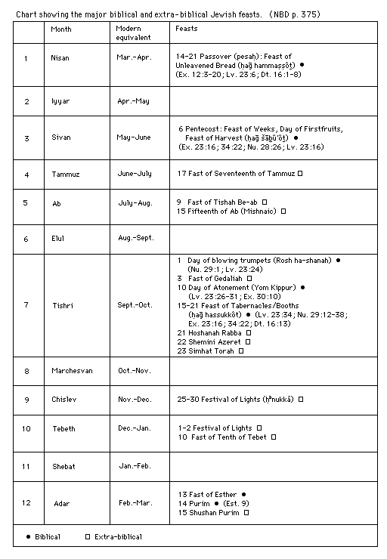

BDAG, p. 928.
Bromiley, G. W. (1988; 2002). The International Standard Bible Encyclopedia, Revised (1:535). Eerdmans.
Freedman, D. N., Myers, A. C., & Beck, A. B. (2000). Eerdmans Dictionary of the Bible (p. 1270). Grand Rapids, Mich.: Eerdmans
MacArthur, J. (2006). The MacArthur New Testament Commentary: John 1-11 (p. 280). Chicago: Moody Press.
Keener, C. S., & InterVarsity Press. (1993). The IVP Bible Background Commentary: New Testament (Jn 7:2). Downers Grove, Ill.: InterVarsity Press.
Godet, p. 614.

