

 is the transitional use of the postpositive conjunction DE, meaning “Now” plus the third person singular imperfect active indicative from the verb DEI, meaning “to be necessary; one must.”
The imperfect tense is a descriptive imperfect, which describes the past action without reference to its completion.
The active voice indicates that the situation produced the state of being what it was.
The indicative mood is declarative for a simple statement of fact.
Then we have the accusative subject of the infinitive from the third person masculine singular person use of the intensive pronoun AUTOS, meaning “He” and referring to Jesus. With this we have the present deponent middle/passive infinitive from the verb DIERCHOMAI, which means “to go through.”
The present tense is a descriptive present, describing what was occurring at that time.
The deponent middle/passive voice is middle/passive in form, but active in meaning with the subject (Jesus) producing the action.
The infinitive is a complementary infinitive that is always used after the verb DEI to complete its meaning. And because of the accusative-infinitive construction we have to include the explanatory word “that” in the translation.

“Now it was necessary that He go”

  is the preposition DIA plus the adverbial genitive of place from the feminine singular article and proper noun SAMAREIA, meaning “through Samaria.”

“through Samaria.”

Jn 4:4 corrected translation
“Now it was necessary that He go through Samaria.”

Explanation:

1. “Now it was necessary that He go”
a. John continues the story of the relocation of Jesus and His disciples from the countryside of Judea to Galilee the second time by telling us it was necessary for Him to go through Samaria.
b. What necessitated that Jesus leave the countryside of Judea?
(1) Some scholars say that Jesus left because He didn’t want to have a confrontation with the Pharisees, Sadducees, or leaders of the Jewish nation this early in His ministry; that is, before people got to hear the message of the gospel. This is certainly true but not the main reason for the necessity of Jesus leaving. However, by going through Samaria, the strict, religious Pharisees would not follow Him and risk being defiled.
(2) Other scholars say that Jesus left because it was the will of the Father, and everything Jesus did was according to the will and plan of the Father. This is certainly true based upon the many statements to this effect which we will see later on in this gospel. “The mission to the Samaritans was unplanned by Jesus but willed by God.” “The Father was sending him there to look for those who would worship him in spirit and truth (Jn 4:23).”
(a) “The use of ‘it is necessary’ reminds one of the fact that usually Jesus moved not in response to human pressure but as a result of the Father’s direction and the determined hour for his life. Did the evangelist merely mean that Samaria was on the way? Or is there some overtone here that Samaria was on the divine agenda? Given the significance of this story in the Johannine structure and the importance of the Samaritan confession (4:42), I cannot help wondering if the evangelist saw in this story more than just a geographical reference at 4:4.”
(b) On His return to Galilee, Jesus ‘had to pass through Samaria’. It was not geographic necessity that compelled Him to do so, despite the fact that it was the most direct of several routes. The road through Samaria was shorter than the coastal road or the road on the east side of the Jordan, which is why many Jews traveled on it, especially at the time of the major religious festivals. But so great was their disdain for the Samaritans that the stricter Jews avoided traveling through Samaria altogether. They preferred instead to be defiled by a lesser evil, thus they would cross the Jordan and travel up its east bank through the largely Gentile region of Perea. They would then cross back into Galilee north of Samaria. Jesus could have easily gone that way. But the Lord was compelled to pass through Samaria and stop in a certain village, not to save time and steps, but because He had a divine appointment there. John frequently used the verb DEI (had to) to speak of Jesus fulfilling the mission given Him by the Father (3:14; 9:4; 10:16; 12:34; 20:9). He was always conscious of doing the Father’s will, which was why He came to earth (6:38; cf. 4:34; 5:30; 17:4; Mt 26:39).”
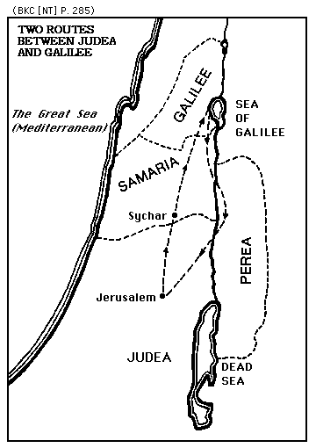
c. Jesus had much to do in healing people, teaching people, presenting the gospel, and training His disciples. This was all part of the Father’s will and plan for His life. This plan did not need to be cut short by the jealousy and hatred of the religious fanatics of Israel. Therefore, Jesus conducts a strategic relocation (not a retreat) to a location where He can accomplish the will of the Father without interference from the leaders of the nation, who didn’t care much for the Jews of Galilee and spent little time there. Don’t think for a moment that Jesus relocated because He was afraid of anyone. What Jesus had already done in cleansing the Temple proved that He wasn’t afraid of the political/religious leaders of Israel.

2. “through Samaria.”
a. In order to go from Judea to Galilee a person had to pass through or go through the territory of Samaria. See the map below. “There were two possible routes from Judea to Galilee. The longer was through Gentile country on the east side of the Jordan; the shorter was through Samaria and was most used in spite of the animosity between the Jews and the Samaritans.”

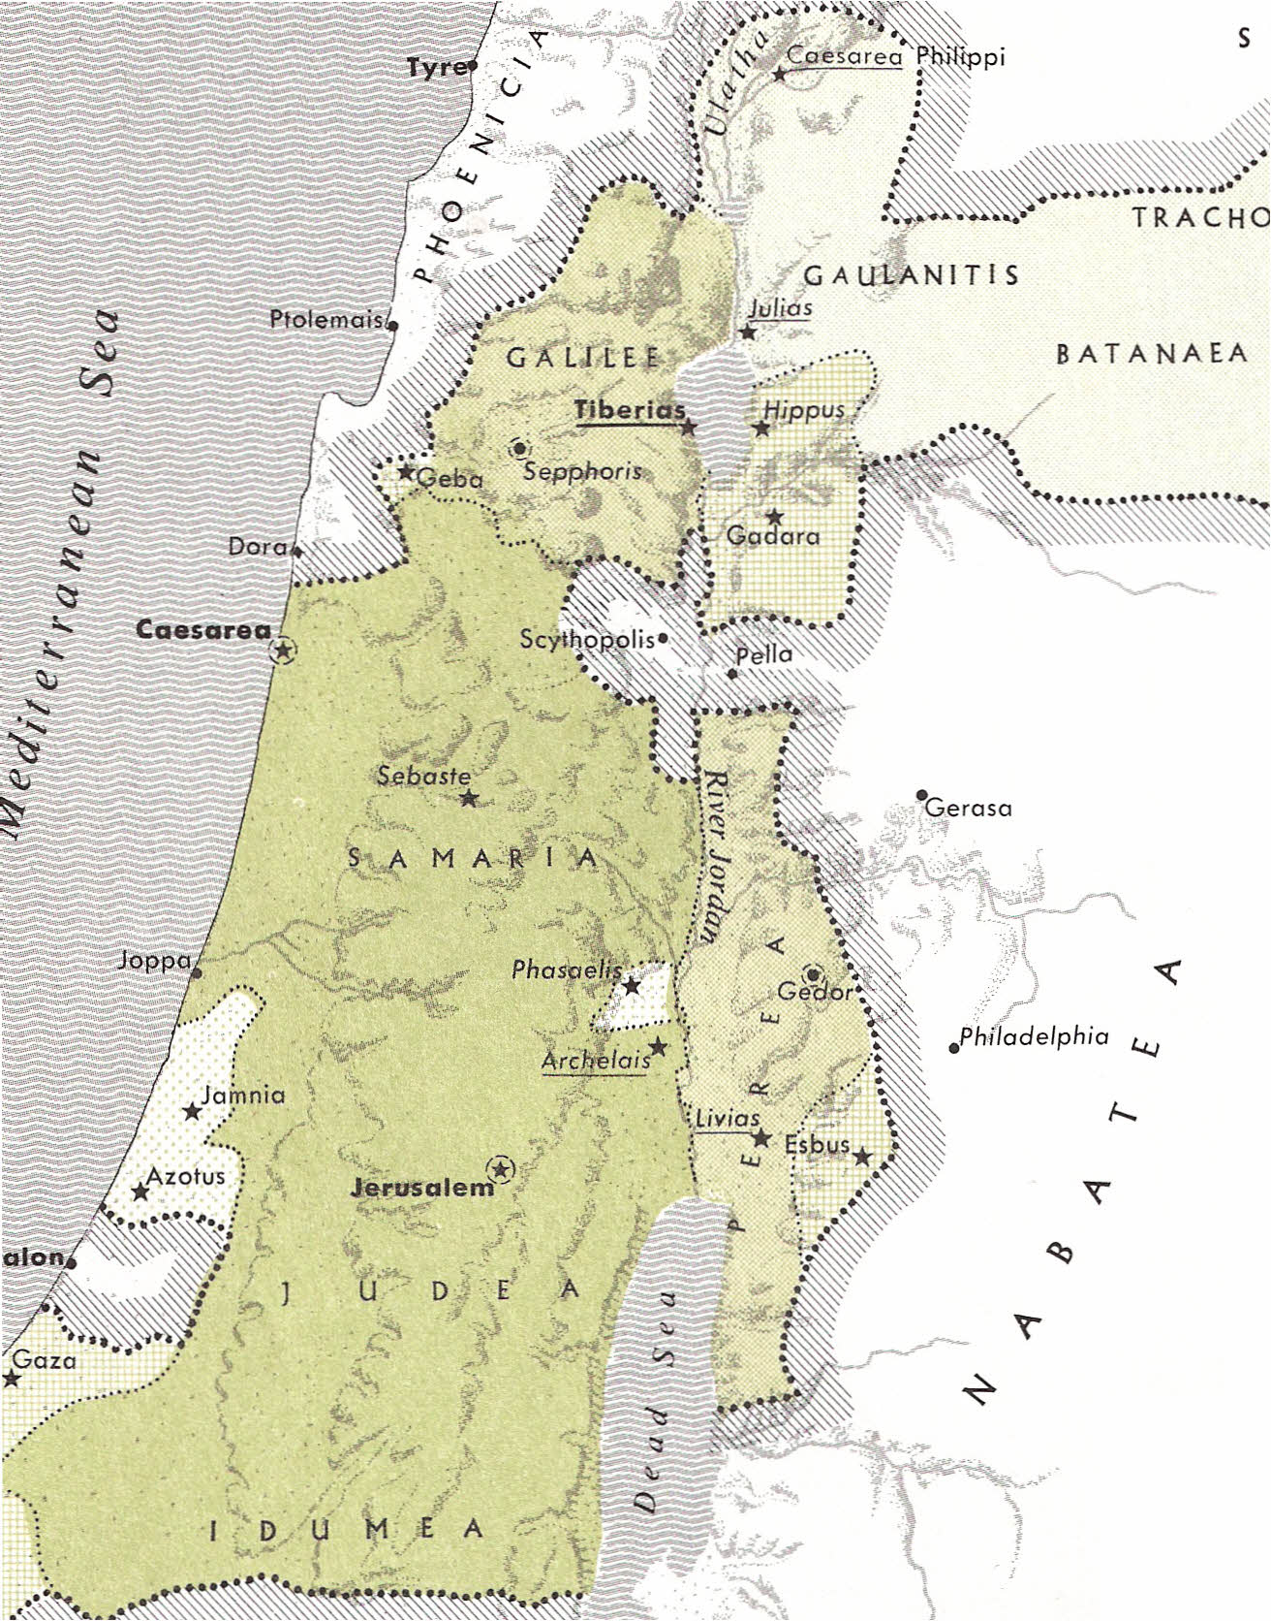

b. Samaria.
(1) “The name ‘Samaria’ was given to the region after the hill of Samaria was selected by Omri to become the capital of the northern kingdom (1 Kg 16:24), about 879 B.C.
(2) ‘Samaria’ is used of the region South of Galilee and North of Judah (Judea). The northern boundary in general is the hills that form the southern edge of the plain of Esdraelon. The southern boundary is less definite, but it approximately follows the southern boundary of Ephraim (Josh 16:5–9), i.e., from Jericho on the east to the sea on the west, including Bethel, Beth-horon, and Gezer. From north to south Samaria was about 40 miles and from east to west about 35 miles.
(3) Because of the importance of Jerusalem as the cultic and political center, it is sometimes forgotten that the northern portion was also the scene of significant events. Abram built an altar at Shechem, and another at Bethel (Gen 12:7f). Jacob received a revelation from God at Bethel (28:10–22), and later erected an altar at Shechem (33:20) and a second time at Bethel (35:7). The bones of Joseph, which had been brought from Egypt, were buried at Shechem (Josh 24:32). Joshua’s charge to Israel, just before his death, was given at Shechem (24:25), and he was buried in the hill country of Ephraim (24:30; Judg 2:9). Shechem was one of the cities of refuge (Josh 21:21). Gideon’s combat with the Midianites took place in Jezreel (Judg 6:33–35). Abimelech’s attempt to become king was centered at Shechem (Judg 9). The ark of the covenant rested in the territory which later belonged to the northern kingdom from the time it was brought over Jordan (Josh 3) until it was taken into battle against the Philistines at Aphek (1 Sam 4:1–4).
(4) When Rehoboam succeeded Solomon (931 B.C.), he went to Shechem to be crowned king (1 Kg 12:1), but the people of the northern tribes rejected him (12:16) and seceded, forming the northern kingdom, later to be known as ‘Israel,’ ‘Ephraim,’ and ‘Samaria.’ Jeroboam, an Ephraimite (1 Kg 11:26), was crowned king and made Shechem his capital (12:20, 25). After Omri had reigned from Tirzah for six years he built a new capital which he called ‘Samaria’ (about 879 B.C.; 1 Kg 16:23f.).
(5) The prophesied judgment of God on the northern kingdom occurred in the siege and fall of Samaria (2 Kg 17:5) and the carrying into captivity of a large portion of the inhabitants. Samaria was repopulated with exiles from other places which Assyria conquered.
(6) After the return from exile, Judah and Benjamin were opposed in their efforts to rebuild the temple by those who had been previously resettled in Samaria (Ezra 4:1, 10). At that time Samaria was part of the Persian province called ‘Beyond the River.’ The breach between Jews and Samaritans probably became permanent with the building of a temple on Mt. Gerizim. According to Josephus this took place in the reign of Darius III Codomannus (335–330).
(7) Samaria came under control of Alexander (about 332 B.C.). In an uprising, his prefect Andromachus was burned to death, and Alexander took vengeance by destroying Samaria and settling a Macedonian colony in its place.
(8) The Maccabean revolt (167 B.C.). The author of Maccabees recorded that Judas was opposed by Apollonius, who had gathered together a force composed of Gentiles and a large number from Samaria (3:10), indicating that Samaria was a stronghold of Hellenistic Jews. According to 2 Macc 6:2, the temple on Mt. Gerizim had been dedicated to Zeus. Josephus tells us that the Samaritans, claiming that they were colonists from the Medes and Persians, requested this change. In the days of Jonathan (about 152–142 B.C.), a portion of southwestern Samaria, as well as Perea, was added to Judea. John Hyrcanus proceeded to take more of Samaria, until he had it all (about 126–104 B.C.). He completely destroyed the city of Samaria. He also captured the Samaritan temple on Gerizim.
(9) The Romans, under Pompey, took over Judea in 63 B.C. He proceeded to ‘liberate’ the hellenized regions, thus Samaria was once again free from Judea. The Jews kept eastern Idumea, Judea, Perea, and Galilee. The last three were considered Jewish provinces, even after Herod the Great (40–4 B.C.) became king of the entire area. A new city (Neapolis, modern Nâblus) was built West of Shechem. Samaria was greatly enlarged by Herod the Great and named Sebaste (‘August’) in honor of the Roman emperor Augustus.
(10) In accordance with Jewish custom, Samaria was considered a non-Jewish country in the Gospels, and is rarely mentioned in the NT (11 times, 4 in the Gospels, 7 in Acts). When traveling from Galilee to Jerusalem, Jews usually went along the border between Samaria and the Decapolis (cf. Lk 17:11) and crossed the Jordan at a ford South of Beth-shean, then southward along the eastern side of the Jordan, recrossing near Jericho, and thence to Jerusalem. (However, Josephus stated that it was the custom of Galileans to ‘pass through’ Samaria at the time of a festival on their way to the Holy City.) The visit of Jesus and His disciples to Samaria (Jn 4) was quite unusual, as the reaction of the woman at Jacob’s well indicates (Jn 4:9). When Jesus sent out the Twelve, he charged them to ‘enter no town of the Samaritans’ (Mt 10:5). On another occasion, when He sent messengers ahead to a village of the Samaritans ‘to make ready for Him,’ they refused to accept Him (Lk 9:52).
(11) After the resurrection of Jesus, the attitude began to change. At the Ascension, the disciples were commanded to be His witnesses ‘in Jerusalem and in all Judea and Samaria and to the end of the earth’ (Acts 1:8). Following the persecution in Jerusalem, the believers (except the apostles) were scattered ‘throughout the region of Judea and Samaria’ (Acts 8:1). Philip (the Deacon, not the Apostle) went to a city of Samaria, probably Sebaste, where he preached and did mighty works (Acts 8:5–7). When the apostles at Jerusalem heard ‘that Samaria had received the word of God’, they sent Peter and John who prayed that the Samaritans also might receive the Holy Spirit; subsequently they preached the gospel to many villages of the Samaritans. The church in Samaria is mentioned together with Judea and Galilee (Acts 9:31).”

Beasley-Murray, p. 59.
Whitacre, p. 101.
Borchert, G. L. (2001, c1996). Vol. 25A: John 1-11 (electronic ed.). Logos Library System; The New American Commentary (p. 198). Nashville: Broadman & Holman Publishers.
MacArthur, J. (2006). The MacArthur New Testament Commentary: John 1-11 (p. 141). Chicago: Moody Press.
Carson, D. A. (1994). New Bible commentary: 21st century edition. (Jn 4:4). Leicester, England; Downers Grove, Ill., USA: Inter-Varsity Press.
Bromiley, G. W. (1988; 2002). The International Standard Bible Encyclopedia, Revised (4:302-303). Eerdmans.

