   □     □   

   □      is the transitional use of the postpositive conjunction DE, meaning “Now” plus the periphrastic construction of the third person singular imperfect active indicative from the verb EIMI plus the nominative masculine singular present active participle of the verb BAPTIZW, which means “to be baptizing.” The verb EIMI, meaning “to be: was” and the participle of BAPTIZW means “baptizing.”
The imperfect tense indicates a continuing, past action.
The active voice indicates that John the Baptist was producing the action.
The indicative mood is declarative for a simple statement of fact.
Then we have the adverbial or adjunctive use of the conjunction KAI, meaning “also” plus the nominative subject from the masculine singular article and noun IWANNĒS, meaning “John” and referring to John the Baptist. This is followed by the preposition EN plus the locative of place from the feminine singular proper noun AINWN, which means “in Aenon.” With this we have the adverb of place used as a preposition EGGUS plus the adverbial genitive of place from the neuter singular article and proper noun SALEM, meaning “near Salim.”

“Now John also was baptizing in Aenon near Salim,”

□    is the causal use of the conjunction HOTI, meaning “because” plus the predicate nominative from the neuter plural noun HUDWR and the adjective POLUS, meaning “much water.” Then we have the third person singular aorist active indicative from the verb EIMI, meaning “to be: there was.”
The imperfect tense is a descriptive imperfect, which describes the past state of being.
The active voice indicates that the situation produced the action of being what it was.
The indicative mood is declarative for a simple statement of fact.
This is followed by the adverb of place EKEI, meaning “there” and referring to Aenon near Salim.

“because there was much water there;”

 is the continuative use of the conjunction KAI, meaning “and,” followed by the third person plural imperfect deponent middle/passive indicative from the verb PARAGINOMAI, which means “to come.”
The imperfect tense is a descriptive imperfect, which describes the past state of being.
The deponent middle/passive voice is middle/passive in form, but active in meaning with the subject (people) producing the action.
The indicative mood is declarative for a simple statement of fact.
Then we have the additive use of the conjunction KAI, meaning “and” plus the third person plural imperfect passive indicative from the verb BAPTIZW, which means “to be baptized.”
The imperfect tense is a descriptive imperfect, which describes the past state of being.
The passive voice indicates that people received the action of being baptized.
The indicative mood is declarative for a simple statement of fact.

“and they were coming and were being baptized;”

Jn 3:23 corrected translation
“Now John also was baptizing in Aenon near Salim, because there was much water there; and they were coming and were being baptized;”

Explanation:

1. “Now John also was baptizing in Aenon near Salim,”
a. The apostle now takes us to another location near the Jordan River, where John the Baptist was continuing his ministry of baptizing. John did not discontinue his ministry after the baptism of Jesus, and identifying Him as the Lamb of God to his disciples. God’s purpose for John did not stop with the beginning of the Lord’s ministry. For a short period of time (a few weeks, perhaps months, they were carrying out the plan of God, preparing people for the kingdom of God by announcing the presence of the Messiah in Israel.
b. See the bottom of the map for the probable location of Salim and Aenon.
(1) “Aenon was on the west side of the Jordan, John having earlier baptized on the east side (Jn 1:28; 3:26; 10:40). We may be sure it was not in Samaritan territory. Eusebius locates it 8 Roman miles South of Scythopolis (Bethshan), for this stretch of land on the west of the Jordan was then not under Samaria but under Scythopolis. Its position is defined by nearness to Salim. Various identifications have been suggested, the most probable being the springs near Umm el-‘Amdân, which exactly suit the position indicated by Eusebius.”
(2) Salim: “Comparison with Jn 1:28; 3:26; 10:40 leads to the conclusion that it was West of the Jordan. Several locations for this site have been suggested, but only two seem plausible. Some modern scholars have identified Salim with the ancient town of Sâlim, about 4 miles Southeast of Nâblus (adjacent to Shechem), and Aenon with AINUN in the WADI FARAH, about 6 miles from Sâlim. This location, however, is in the heart of Samaritan territory, and it is almost unthinkable that a strict Jew would conduct his ministry there. Even Jesus’ interaction with the woman at Jacob’s well in Samaria (Jn 4) must be viewed as a mere interlude. Moreover, a high ridge separated Sâlim and AINUN, hardly making them adjacent.
In the 4th century Eusebius and Jerome identified it with the village Salumias, 8 Roman miles South of Scythopolis (ancient Beth-shean); the name may be preserved in Tell Sheikh Salim, which is in this area. Nearby is a place with seven springs that may represent AENON (‘place of springs’); the sixth-century Madeba Map has an Aenon in this vicinity. Apparently the area did not belong to Samaria in John’s day but was subject to Scythopolis, one of the cities of the Decapolis. While this identification cannot be asserted dogmatically, it is probably the best made to date.”

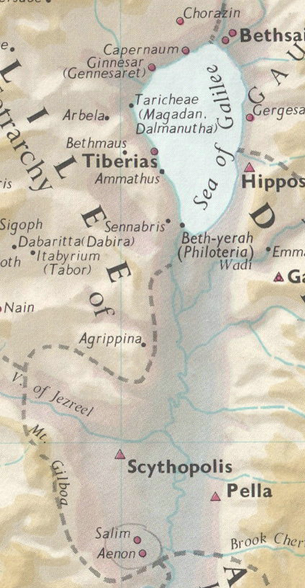

2. “because there was much water there;”
a. John worked where there was sufficient water to accomplish what he needed to do in baptizing people. John could not baptize people without enough water for immersion. The word “much” implies that people were being immersed and not sprinkled. “Texts cited to show early believers were immersed include Mt 3:6 , ‘baptized of him in Jordan,’ cf. Mt 3:16; Mk 1:9; also Jn 3:23, ‘because there was much water there,’ and Acts 8:38-39, ‘when they were come up out of the water,’ cf. Acts 16:13–15.”
b. The word much also suggests that the location of these two cities was very close to the Jordan River or one of its tributaries.

3. “and they were coming and were being baptized;”
a. People were still coming to John to be baptized, because the ministry of Jesus was just getting started. People were also coming to Jesus at this point and John was certainly now telling them that Jesus was the Messiah and had begun His ministry in Israel.
b. The news about John was widespread and had been circulating for over a year. The news about Jesus was only a couple of weeks or months old and just beginning to be circulated. “John’s Gospel gives some further information about baptism that none of the Synoptic writers records. The Baptist’s ministry did not stop with the baptism of Jesus. He continued to baptize at Aenon near Salim. Meanwhile Jesus also was baptizing in Judea (verse 22), although it is explained later that the disciples, not Jesus, did the actual baptizing (Jn 4:2). While some people still came to John, more were now going to Jesus (Jn 3:26; 4:1).”
c. The fact that people were coming to John shows their positive volition to the message of the gospel and the kingdom. Eventually these crowds would move from listening to John to listening to Jesus, just as John predicted, “He must increase, but I must decrease.”
d. “The significant circumstance was that both Jesus and John the Baptist were baptizing in the same district. The dispute between John the Baptist’s disciples and a certain Jew provided the occasion for a dialogue between John and his disciples. The unnamed Jew was concerned about ritual matters, and this called for a distinction between John’s baptism and Jewish ceremonial rites (25–26). The essential factor in John’s baptism was the prior requirement of repentance, and the synoptics show that Jesus continued the same theme.” Some commentators make a big issue out of what the differences and similarities might have been between the baptism of Jesus and the baptism of John and what they both meant. This misses the simple point being made by the context of the gospel of John up to this point. Jesus baptized so people would recognize that He was the person about Whom John had testified, “He will baptize you with the Spirit” (Jn 1:33). The people could not recognize the baptism of the Spirit, which is invisible, but they could recognize someone baptizing with water in the same manner that John was baptizing. Jesus did what John had been doing, so that He could be easily identified by the people as the Person John was proclaiming to be the Messiah. This is why Jesus did what John was doing and did it in a location near John. To speculate on what kind of baptism Jesus was performing and what the deep theological implications of it were is to go into ‘overthink’ and miss the simple point of John pointing to Jesus as the Messiah and Jesus making Himself easily recognizable to the people.

BDAG, p. 760.
Bromiley, G. W. (1988; 2002). The International Standard Bible Encyclopedia, Revised (1:60). Eerdmans.
Bromiley, G. W. (1988; 2002). The International Standard Bible Encyclopedia, Revised (4:285). Eerdmans.
Evans, W., & Coder, S. M. (1998, c1974). The Great Doctrines of the Bible. (p. 279). Chicago: Moody Press.
Bromiley, G. W. (1988; 2002). The International Standard Bible Encyclopedia, Revised (1:412). Eerdmans.
Carson, D. A. (1994). New Bible Commentary : 21st century edition. Rev. ed. of: The new Bible commentary. 3rd ed. / edited by D. Guthrie, J.A. Motyer. 1970. (4th ed.) (Jn 3:22). Leicester, England; Downers Grove, Ill., USA: Inter-Varsity Press.

