  □  

  □   is the transitional use of the postpositive conjunction DE, meaning “Now” plus the third person singular imperfect active indicative from the verb EIMI, meaning “to be: was.”
The imperfect tense is a descriptive imperfect, which describes the past state of being.
The active voice indicates that Philip produced the state of being from somewhere.
The indicative mood is declarative for a simple statement of fact.
Then we have the nominative subject from the masculine singular article and proper noun PHILIPPOS, transliterated as “Philip.” This is followed by the preposition APO plus the ablative of origin from the feminine singular proper noun BĒTHSAIDA, which means “from Bethsaida.”

“Now Philip was from Bethsaida,”

 is the preposition EK plus the ablative of origin/source from the feminine singular article and noun POLIS, meaning “from the city.” Finally, we have the possessive genitive from the masculine singular proper nouns ANDREAS and PETROS, connected by the conjunction KAI, meaning “of Andrew and Peter.”

“from the city of Andrew and Peter.”

Jn 1:44 corrected translation
“Now Philip was from Bethsaida, from the city of Andrew and Peter.”

Explanation:

1. “Now Philip was from Bethsaida,”
a. John interrupts his story with a slightly parenthetical thought, in order to tell us where Philip was from—the city of Bethsaida, which also happened to be the city where Andrew and Peter lived. Philip’s name is Greek, which indicates that strong Hellenistic influence in the city of Bethsaida.
b. Therefore, we find that Andrew, Peter, John, James, Philip and Nathanael all live in the same city on the north shore of the Sea of Galilee. (To give you some idea of the scale of the map below, the straight line distance over the water on the Sea of Galilee from north to south is about 13 miles and about 8 miles east to west at its widest part. The straight line distance from Bethsaida to Cana is 20 miles.)

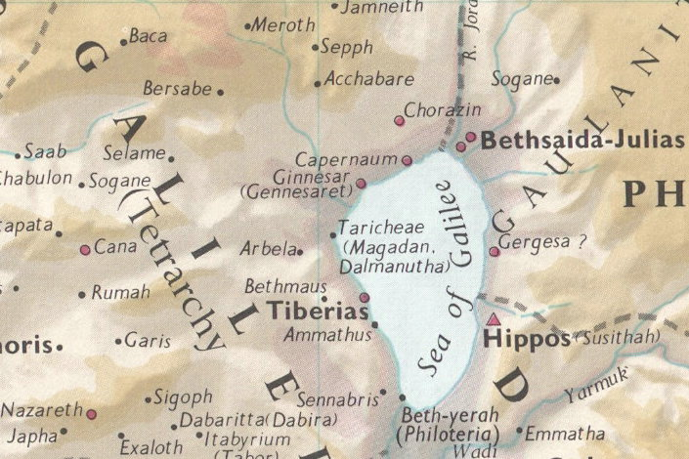

c. “The Gospels themselves hint at this great fishing activity and its economic importance [in Bethsaida]. At least four of the disciples — Peter, Andrew, James, and John — were fishermen, and there is no reason to believe that they were poor men. Mark intimated that the family of Zebedee was one of substance when he mentioned the hired servants left to help the father when James and John departed to follow Jesus (Mk 1:20). That John was acquainted with the household of the high priest in Jerusalem also indicates that his family was one of some means and influence.”

2. “from the city of Andrew and Peter.”
a. Philip was from the same city as Andrew and Peter. Nathanael was the friend of Philip and was from the city of Cana according to Jn 21:2, but may have been living and working with the others in Bethsaida. It is highly likely that James and his brother John also lived in Bethsaida, since all of them were fishermen and all traveled together to hear John the Baptist. “Mark says that Simon and Andrew were from Capernaum (Mk 1:21, 29; 2:1), and excavations confirm that early Christians thought that Peter’s home was there. [It is quite possible that Andrew and Peter were originally from Bethsaida, but now had a home in Capernaum or that Peter had a home in both places. It is not unlikely that as fishermen in a fishing cooperative with James and John (Mk 1:19) they took their boats back and forth between Capernaum and Bethsaida.” If you were a fisherman that had to row your boat several miles on the lake from one town to the next, wouldn’t you have places to stay in both cities, so that you wouldn’t have to row your boat home all the time?
b. The name ‘Bethsaida’ means “‘house of fishing’ or ‘fisherman’s house’. It is a town on the north shore of the Sea of Galilee. Many scholars believe there were two towns of the same name, one to the east and the other to the west of the Jordan. The precise locations are disputed. Bethsaida was the home of at least three of Jesus’ disciples. In Jn 12:21 Philip is identified as being from “Bethsaida in Galilee,” and in Jn 1:44 Bethsaida is described as “the city of Andrew and Peter.” Some think James and John also came from the same city. There are reasons to believe that Bethsaida was a city of some importance. With Chorazin and Capernaum, it is one of the cities (although it is twice designated a ‘village,’ in Mk 8:26) where Jesus did most of His mighty works (Mt 11:20–24; Lk 10:13–15). Further, if there were but one Bethsaida it would undoubtedly be the one lying East of the Jordan, which Philip the tetrarch rebuilt in honor of Julia, the daughter of Caesar Augustus, and made into his capital. It was at Bethsaida that Jesus healed a blind man by spitting on his eyes and laying His hands on him (Mk 8:22–26). Context would seem to locate this East of the Jordan (the “other side” from the district of Dalmanutha, Mk 8:10, 13; on the way to the villages of Caesarea Philippi, Mk 8:27).
The evidence for a Bethsaida East of the Jordan is strong. Josephus, who identified Bethsaida as the site Philip developed into the city of Julias, located it as lying near the Jordan in ‘Lower Gaulanitis.’ Both Pliny and Jerome agree with this location. The problem arises with the Gospel materials. After the feeding of the five thousand in a place Luke connects with “a city called Bethsaida” (Lk 9:10), Jesus sends His disciples by boat to “the other side, to Bethsaida” (Mk 6:45). Jesus walks on the water to the disciples, who are rowing against a strong wind; and ‘when they had crossed over, they came to land at Gennesaret’ (Mk 6:53). John’s account indicates that the disciples started across the sea to Capernaum. The following day the crowds, who had been miraculously fed on five barley loaves and two fish, follow by boat and find Jesus “on the other side of the sea,” at Capernaum (Jn 6:16–25). A normal reading of these verses assumes a Bethsaida West of the Jordan as well as another to the east. The position is strengthened by several supporting considerations: (1) Philip, Peter, and Andrew are from “Bethsaida in Galilee” (Jn 1:44 with 12:21); (2) in Acts 1:11 the disciples are called “men of Galilee,” which would be incorrect if at least three were from Gaulanitis; (3) the close connection with Chorazin and Capernaum as the center of Jesus’ mighty works does not favor a Gentile city East of the Jordan (Mt 11:20–24). In fact, Bethsaida is contrasted with the Gentile cities of Tyre and Sidon. Further, we have recorded only three brief visits of Jesus to the foreign peoples East of the Sea of Galilee. Those who argue against a second Bethsaida West of the Jordan point out how unlikely it would be that two towns of the same name should exist so close to each other.
The exact location of Bethsaida Julias is still uncertain, although most scholars identify it with El-Tell, 2 miles North of the Sea of Galilee just East of the Jordan, along with Khirbet el-Araj, the nearby fishing settlement on the shore of the lake. Traces of an aqueduct and a Roman road indicate a connection between the original fishing village and the larger city established by Philip on higher ground to the north. The transfer of the name ‘house of fishing’ to the larger settlement is understandable. Et-Tell is located near an open plain (about 2 miles down the east side of the lake) with rich soil and thick grass. This corresponds to the ‘green grass’ of Mk 6:39 and the ‘much grass’ of Jn 6:10 where Jesus fed the five thousand. ‘Ain et-Tabigha, about 3 miles Southwest of the mouth of the Jordan, is usually mentioned as the location of the ‘second Bethsaida’ West of the Jordan.”
c. “Josephus reports that sometime before 2 B.C. under the tetrarch Philip Herod, Bethsaida’s status increased to that of a polis [from that of a village] and was renamed Bethsaida Julias after the Emperor Augustus’ daughter. Philip is also said to be entombed at Bethsaida. Several miracles in Jesus’ ministry are reported to have occurred at or near Bethsaida, such as the feeding of 5000 (Mk 6:30–44), Jesus’ walking on water (Mk 6:45–52), and the healing of a blind man (Mk 8:22–26). Nevertheless, the inhabitants of Bethsaida appear to remain largely unmoved by these wonders, as the city is cursed by Jesus along with Chorazin for not heeding his message (Mt 11:21–22). Excavations on the mound of Bethsaida, modern et-Tell, began in 1987 and have unearthed many remains dating from Iron II to the early Roman period, including several fishing implements such as anchors, hooks, and net weights.”

Lenski, p. 162.
Bromiley, G. W. (1988; 2002). The International Standard Bible Encyclopedia, Revised (2:392). Eerdmans.
Keener, C. S., & InterVarsity Press. (1993). The IVP Bible Background Commentary: New Testament (Jn 1:44). Downers Grove, Ill.: InterVarsity Press.
Bromiley, G. W. (1988; 2002). The International Standard Bible Encyclopedia, Revised (1:475). Eerdmans.
Freedman, D. N., Myers, A. C., & Beck, A. B. (2000). Eerdmans Dictionary of the Bible (p. 174). Grand Rapids, Mich.: W.B. Eerdmans

