

 is the adversative use of the postpositive conjunction DE, meaning “but” with nominative masculine plural aorist active participle of the verb LAMBANW, which means “to take.”
The aorist tense is a culminative aorist, which regards the entire past action from the standpoint of its completion. It is translated with the English auxiliary verb “having taken.”
The active voice indicates that Saul’s disciples/students produced the action.
The participle describes attendant circumstances that precede the action of the main verb.
Then we have the nominative subject from the masculine plural article and noun MATHĒTĒS with the possessive genitive from the third person masculine singular personal use of the intensive pronoun AUTOS, meaning “his disciples/students.” This is followed by the adverbial genitive of time from the feminine singular noun NUX, meaning “during the night” or “at night.” The direct object “[him]” is implied from the context of what is being said and can be added in the English translation for clarity.

“but his disciples, having taken [him] at night,”

 □  is the preposition DIA plus the adverbial genitive of place from the neuter singular article and noun TEICHOS, meaning “through the wall.” Then we have the third person plural aorist active indicative from the verb KATHIĒMI, which means “to let down Lk 5:19; Acts 9:25; passive voice 10:11; 11:5.”
The aorist tense is a constative/historical aorist, which views the entire past action as a fact.
The active voice indicates that the disciples of Saul produced the action.
The indicative mood is declarative for a simple statement of fact.
This is followed by the accusative direct object from the third person masculine singular personal use of the intensive pronoun AUTOS, meaning “him” and referring to Saul. The words “an opening in,” which are used in the NASV are clearly not in the Greek text, but were added for clarity because they are used in Paul’s description of this event in 2 Cor 11:33.

“let him down through the wall,”

  is the nominative masculine plural aorist active participle from the verb CHALAW, which means to lower or “let down Mk 2:4; Lk 5:4f; Acts 27:17, 30; Acts 9:25; 2 Cor 11:33.”
The aorist tense is a constative/historical aorist, which views the entire past action as a fact.
The active voice indicates that Saul’s disciples produced the action.
The participle expresses attendant circumstances that are coterminous with the action of the main verb.
Finally, we have the preposition EN plus the locative of place (‘in a basket’) or instrumental of means (‘by means of a basket’) from the feminine singular noun SPURIS, which means “a basket, hamper Acts 9:25; Mt 15:37; 16:10; Mk 8:8, 20.” The direct object “[him]” is implied from the context of what is being said and can be added in the English translation for clarity.

“lowering [him] in a basket.”

Acts 9:25 corrected translation
“but his disciples, having taken [him] at night, let him down through the wall, lowering [him] in a basket.”

Explanation:

1. “but his disciples, having taken [him] at night,”
a. In contrast to the Jews’ plot to do away with Saul, Saul’s students have their own plan to rescue him.
b. The fact that Saul had students/disciples tells us that his message in Damascus was well received by a few people. These students or disciples had been listening to Saul teach and were convinced of the truthfulness and accuracy of his message.
c. Saul’s disciples would certainly have included that invisible hero Ananias. But of the rest we have no further knowledge.
d. The fact that Saul’s disciples were willing to risk their lives to save him says volumes concerning their spiritual growth and the importance Saul played in their lives.
e. Saul’s disciples help Saul sneak out of town in the middle of the night, when there was greater chance of success.

2. “let him down through the wall, lowering [him] in a basket.”
a. The means by which Saul escapes the guarded city is by lowering him down from a second story window, using a wicker or rope basket. It was not God’s will, plan, or purpose for Saul to become a martyr for Christ. God’s will for him was to sneak away from the agents of Satan in the middle of the night. Saul spent the rest of that night and the next day heading down the same road on which he had seen the Lord back to the city of Jerusalem.
b. The method used was silent, safe, and effective. It was a simple plan that was easy to execute in the dark, and could be carried out in a matter of a few minutes without being detected.
c. Paul’s account of this incident is found in 2 Cor 11:32-33, “In Damascus the official of Aretas the king was guarding the city of the Damascenes to arrest me, and through a window in a rope basket [Paul calls it a SARGANĒ = “a rope basket”; Luke calls it a SPURIS = “a basket, hamper; “The SPURIS was a large hamper, possibly of rope, of sufficient size and strength for Paul to be lowered in it from the wall of Damascus. The apostle himself describes this basket as a SARGANĒ, a plaited basket, sometimes more specifically a fish basket.”] I was lowered through the city wall, and so I escaped his hands.”
(1) “Aretas was the father-in-law of Herod Antipas, and king of Arabia Petraea. His daughter returned to him on the occasion of her husband’s entering into an adulterous alliance with Herodias, the wife of Herod-Philip, his half-brother (Lk 3:19, 20; Mk 6:17; Mt 14:3). This led to a war between Aretas and Herod Antipas. Herod’s army was wholly destroyed (A.D. 36). Aretas, taking advantage of the complications of the times on account of the death of the Emperor Tiberius (A.D. 37), took possession of Damascus. At this time Paul returned to Damascus from Arabia.”
(2) House on a wall in Damascus. From such a place Paul was lowered in a basket.”

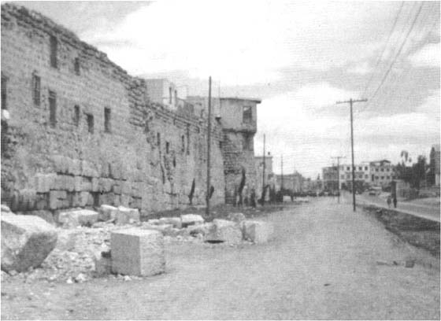

Arndt, W., Danker, F. W., & Bauer, W. (2000). A Greek-English Lexicon of the New Testament and other early Christian literature. (3rd ed.) (p. 492). Chicago: University of Chicago Press.
Arndt, W., Danker, F. W., & Bauer, W. (2000). A Greek-English Lexicon of the New Testament and other early Christian literature. (3rd ed.) (p. 1075). Chicago: University of Chicago Press.
Arndt, W., Danker, F. W., & Bauer, W. (2000). A Greek-English Lexicon of the New Testament and other early Christian literature. (3rd ed.) (p. 940). Chicago: University of Chicago Press.
Bromiley, G. W. (1988; 2002). The International Standard Bible Encyclopedia, Revised (1:438). Eerdmans.
Easton, M. (1996, c1897). Easton’s Bible Dictionary. Oak Harbor, WA: Logos Research Systems, Inc.
Bromiley, G. W. (1988; 2002). The International Standard Bible Encyclopedia, Revised (3:701). Eerdmans.

