😐   □ □   □ □  

😐   is the continuative use of the conjunction KAI, meaning “And” plus the nominative masculine singular aorist middle participle of the verb PROSKALEW, which means “to summon; to call to oneself.”
The aorist tense is a constative/historical aorist, which views the entire past action as a fact.
The middle voice is an indirect middle, which emphasizes the personal responsibility of the subject in producing the action.
The participle is a temporal participle that precedes the action of the main verb and is translated “after summoning.”
Then we have the accusative direct object from the masculine plural cardinal adjective DUO, meaning “two” plus the genitive of the whole (partitive genitive) from the masculine plural article and noun EKATONTARCHĒS, which means “of the centurions.” The word  is a scribal addition and not part of the original text. This is followed by the third person singular aorist active indicative from the verb EIPON, which means “to say: he said.”
The aorist tense is a constative/historical aorist, which views the entire past action as a fact.
The active voice indicates that the tribune produced the action.
The indicative mood is declarative for a simple statement of fact.

“And after summoning two of the centurions, he said,”

 □ □   is the second person plural aorist active imperative from the verb HETOIMAZW, which means “to prepare.”
The aorist tense is a constative aorist, which views the action in its entirety.
The active voice indicates that the two centurions are to produce the action or cause it to be produced by others.
The imperative mood is a command.
Then we have the accusative direct object from the masculine plural noun STRATIWTĒS and the cardinal adjective DIAKOSIOI, meaning “two hundred soldiers.” This is followed by the conjunction HOPWS, which is used with the subjunctive mood is the verb that follows to introduce a purpose clause (it is equivalent to HINA), and is translated “in order that.” Then we have the third person plural aorist deponent passive subjunctive from the verb POREUOMAI, which means “to go, travel, or proceed.”
The aorist tense is a constative/futuristic aorist, which views the future action in its entirety.
The active voice indicates that the two hundred soldiers will produce the action.
The subjunctive mood is a subjunctive of purpose with an element of contingency.
This is followed by the preposition HEWS plus the adverbial genitive of measure of extent of space from the feminine singular proper noun KAISAREIA, meaning “as far as Caesarea.”

“‘Prepare two hundred soldiers, in order that they might go as far as Caesarea,”

 □ □   is the additive use of the conjunction KAI, meaning “and” plus the accusative direct object from the masculine plural noun HIPPEUS and the cardinal adjective HEBDOMĒKONTA, which means “seventy cavalry.” Then we have the additive use of the conjunction KAI, meaning “and” plus the accusative direct object from the masculine plural noun DEXIOLABOS and the cardinal adjective DIAKOSIOI, meaning “two hundred spearmen.” This word is a “word of uncertain meaning, but certainly a military technical term according to a sixth century writer; it referred to a light-armed soldier, perhaps a bowman, slinger, or spearman.” The Vulgate (Latin translation) reads lancearios or ‘lancers, spearmen’; the Syriac translation says ‘shooters, slingers with the right hand. Finally, we have the preposition APO plus the adverbial genitive of time (indicating the time from which the event began) from the feminine singular ordinal adjective TRITOS, meaning “third” plus the noun HWRA, meaning “hour” plus the descriptive genitive from the feminine singular article and noun NUX, meaning “of the night.”

“and seventy cavalry and two hundred spearmen from the third hour of the night.’”

Acts 23:23 corrected translation
“And after summoning two of the centurions, he said, ‘Prepare two hundred soldiers and seventy cavalry and two hundred spearmen, in order that they might go as far as Caesarea from the third hour of the night.”

Explanation:

1. “And after summoning two of the centurions, he said,”
a. Having received the report of the assassination plot against Paul from Paul’s nephew and having dismissed the young man, the tribune immediately springs into action. This is no time to hesitate. He needs to take action now, which gives him the element of surprise.
b. The tribune calls for two of his company commanders, his centurions, and issues verbal orders to them.
c. Notice that the tribune is not going to undertake this duty himself, but entrust it to his subordinates. Why? Part of the plan to deceive the Jews about the location of Paul is for the tribune to remain in Jerusalem performing his normal duties. This will make the Jews think that Paul is still there with him. Remember that some sort of Jewish delegation is about to come to him to ask him to send Paul down to the Sanhedrin the next day. Claudius has to be there to receive this Jewish delegation and to stall them by not giving an immediate decision, and then tell them later that he will send Paul to them when he gets around to it. While he is stalling the Jews, Paul will be making his way out of Jerusalem and out of the reach of these assassins.

2. “‘Prepare two hundred soldiers and seventy cavalry and two hundred spearmen,”
a. The tribune now tells the centurions how many men to take with them—a total of 470 soldiers will escort Paul. The entire contingent of soldiers in the garrison was 600. Therefore, the tribune is dispatching 78% of his combat troops to this mission. (“The Roman prefect’s headquarters were in Caesarea. He had at his disposal a force of three thousand soldiers made up of five cohorts each of six hundred men. These were not Roman legionaries, but mainly auxiliaries enlisted in the provinces. Their officers had, however, to be Roman citizens. The main contingent was stationed at Caesarea. One section of the force, comprising a cohort of five hundred infantry and a hundred cavalry, was permanently stationed in Fort Antonia in the north-western corner of the temple area.”) Even if there are 47 Jewish assassins his men have a ten to one advantage. Why so many soldiers? “In A.D. 66 we hear from the writings of Josephus that the governor of Syria with thirty-three thousand men only narrowly escaped annihilation from ill-equipped Jewish rebels at the pass that leads down from Jerusalem to Lydda.”
b. The two hundred soldiers are light infantry. The seventy horsemen are cavalry, or what we would think of as armored forces, such as tanks. The two hundred spearmen are lancers, that is, infantry who can throw spears or javelins, which are the equivalent of mortars. Therefore, the commander sends a combined-arms force to accomplish this mission.
c. The preparations would have taken less than a half hour for these men to assemble and be ready to move out of the Fortress. Such a large force moving out of the Fortress would normally draw the attention of a lot of people. Therefore, the timing of this move is important, which is why Luke emphasizes it in the next statement.

3. “in order that they might go as far as Caesarea from the third hour of the night.’”
a. The purpose and timing of the mission are now given. The purpose of the mission is to get Paul from Jerusalem to Caesarea. This is a distance of a little over sixty miles with the city of Antipatris being the half-way point (thirty-five miles from Jerusalem). The soldiers would travel northwest from Jerusalem to Antipatris, and then north from Antipatris to Caesarea for a distance of about twenty-five miles. It would be a two-day trip. Claudius Lysias “probably would have made this transfer sooner or later under any circumstances. The Jews were charging Paul with a capital crime, and only the procurator [Felix in Caesarea] had jurisdiction over such cases. Further, Paul was a Roman citizen, and that too placed Paul under the procurator rather than a lesser official such as himself.” Were the Romans really capable of marching these distances in a day? “The first day’s journey [from Jerusalem to Antipatris] is mostly downhill. We have evidence of Roman troops traveling these kinds of distances in this amount of time from Caesar’s book Gallic Wars—forty-five miles covered with full baggage train in twenty-eight hours, with three hours rest; in very adverse conditions twenty-seven miles was covered in one night (Plutarch’s book Mark Antony). Josephus says Sebaste in Samaria could be reached from Jerusalem in a day, and it was forty-two miles away.”
b. The “third hour of the night” refers to 9 p.m. in the evening, since sundown in the spring would occur at about 6 p.m. This would give the soldiers the cover of darkness to hide Paul in their group of 470. (All they had to do to hide him was to throw a Roman soldier’s outer coat over him and put a helmet on him. He could easily be disguised in the dark.) By leaving at the third hour of the night, everyone would have been finished with dinner and heading to bed, if not already there. Thus the commotion of 470 Roman soldiers leaving Fortress Antonia would be less noticed than in broad daylight.
c. This would give Paul and the Roman soldiers a head start on Paul’s assassins of at least nine hours, which means that they were already in or near Antipatris when the assassins realized Paul was no longer in Jerusalem. And even if the group of forty-plus assassins decided to pursue Paul and the Romans they would have to travel all day to Antipatris and then would encounter the four hundred light infantry and lancers returning to Jerusalem (see verse 32). Obviously the centurion in charge of these men would be warned by the tribune to be on the lookout for a group of forty men heading toward Antipatris. If he encountered them, he was to detain them or turn them around and head them back to Jerusalem. In either case, this would buy time for the cavalry and Paul to make it to Caesarea in half a day (they could travel twice as fast as the infantry and no group of forty assassins was going to catch up to them).
d. This also tells us why the tribune summoned two centurions. One would be in charge of the group of cavalry that went all the way to Caesarea, while the other centurion would be in charge of the group of infantry and lancers that only went as far as Antipatris. The tribune had a well thought out plan. He uses the military axioms of surprise, cover and concealment, massing his forces, and the use of combined arms. He knew exactly what he was doing.
e. Pictures of these Roman soldiers come from Peter Connolly’s book, Greece and Rome At War, p. 304-307; 1981, Macdonald Phoebus Ltd.

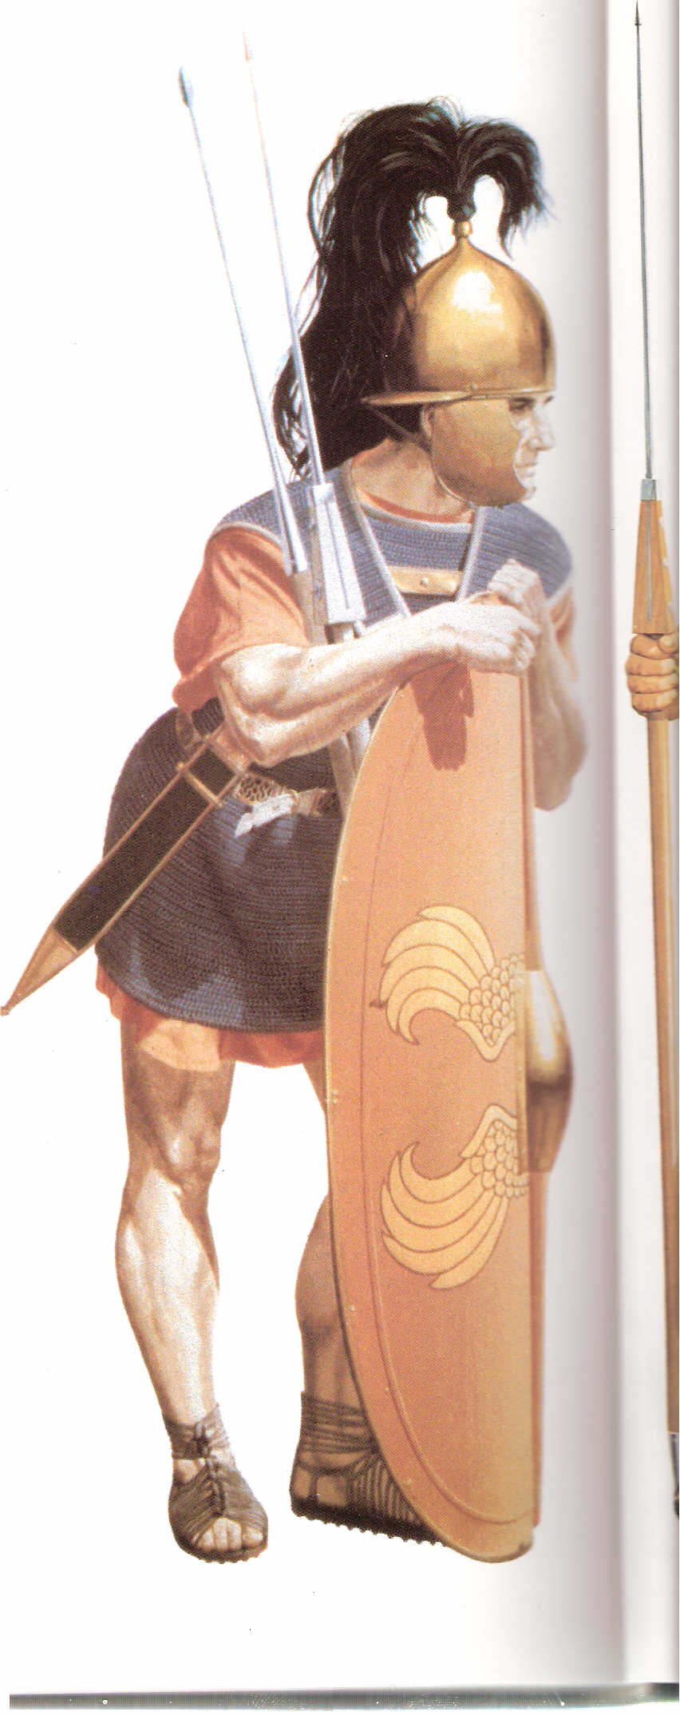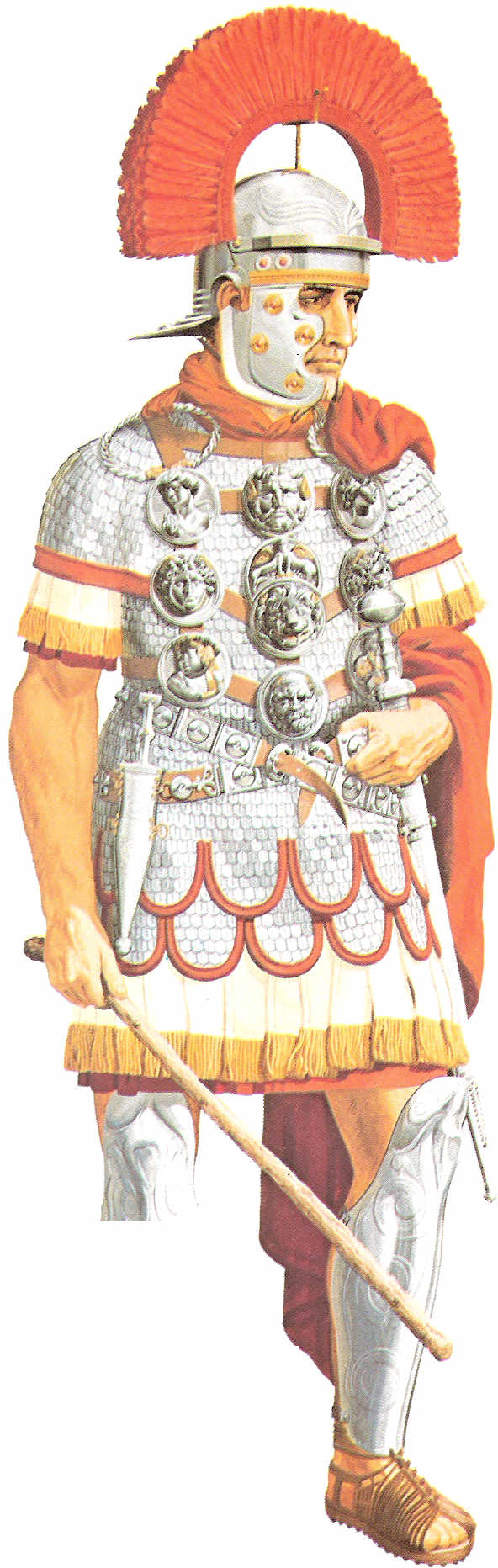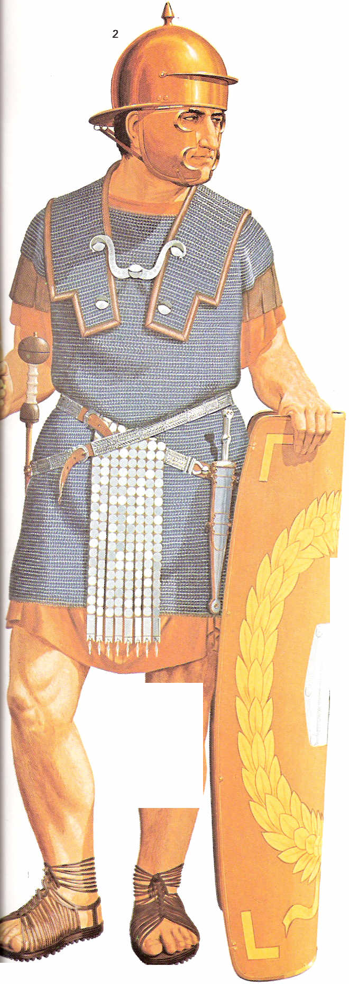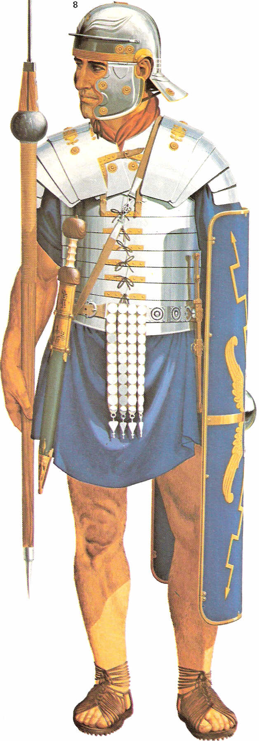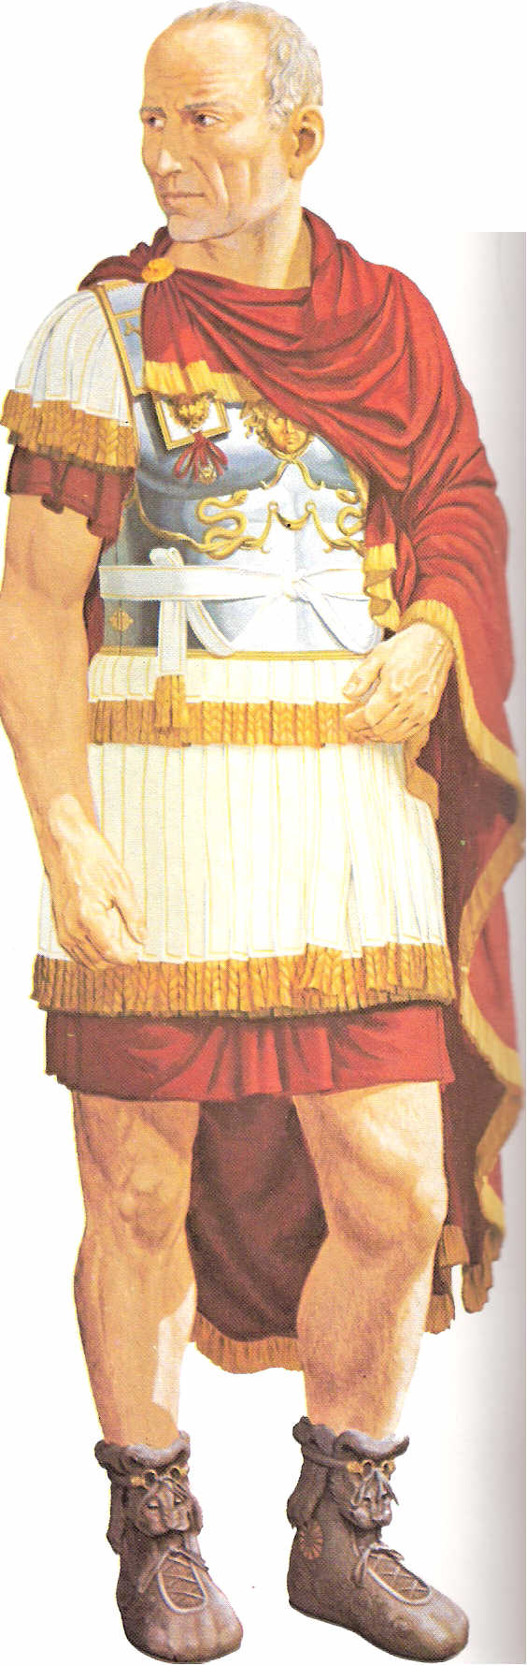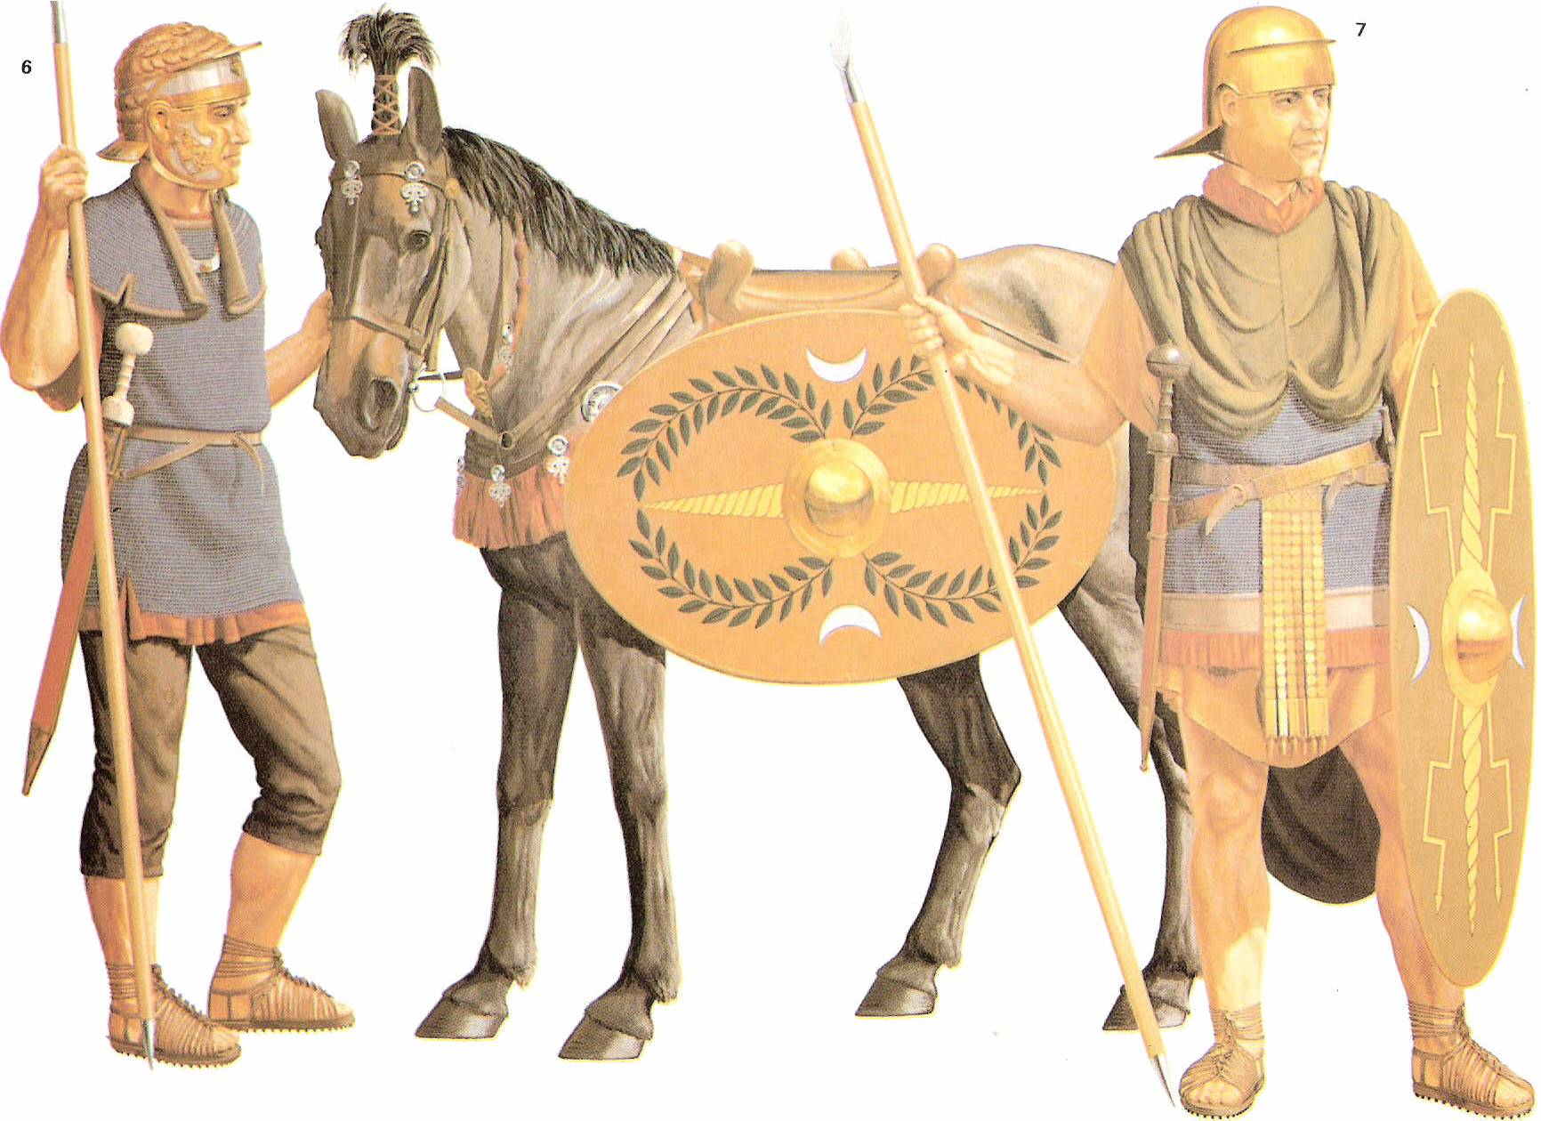
Explanation of pictures from left to right:
1. Caesarian legionary.
2. A centurion of mid 1st century A.D. with all his decorations on his chest.
3. Legionary of the first half of the 1st Century A.D.
4. A legionary of the second half of the 1st century A.D.
5. A provincial legate of the 1st-2nd century A.D (Felix and Festus would have dressed like this).
6. An auxiliary cavalryman and infantryman of the mid 1st century A.D.

BDAG, p. 400.
BDAG, p. 718.
BDAG, p. 423, meaning 3.a.
BDAG, p. 480.
Arndt, W., Danker, F. W., & Bauer, W. (2000). A Greek-English Lexicon of the New Testament and other early Christian literature. (3rd ed.) (p. 217). Chicago: University of Chicago Press.
Barrett, ICC, Vol 2, p. 1077f.
du Toit, A. (1998). The New Testament Milieu. Halfway House: Orion.
Witherington, p. 697.
Polhill, p. 474.
Witherington, p. 697.
Robertson, A. (1997). Word Pictures in the New Testament. (Acts 23:23). Oak Harbor: Logos Research Systems. Polhill, p. 474.

