     □

   is the third person plural aorist active indicative from the verb KATANTAW, which means “to get to a geographical destination, come (to), arrive (at), reach, Acts 16:1; 18:19, 24; 21:7; 25:13; 27:12; 28:13; 20:15.”
The aorist tense is a constative/historical aorist, which views the entire past action as a fact.
The active voice indicates that Paul, Priscilla, and Aquila produced the action.
The indicative mood is declarative for a simple statement of fact and reality.
Then we have the continuative use of the postpositive conjunction DE, meaning “Then.” This is followed by preposition EIS plus the accusative of place/direction from the feminine singular proper noun EPHESOS, meaning “to Ephesus.”

“Then they came to Ephesus,”

 is the accusative direct object from the masculine plural combination of KAI and the demonstrative pronoun EKEINOS, meaning “and those ones” or “and them.” Then we have the third person singular aorist active indicative from the verb KATALEIPW, which means “to leave (behind): he left.”
The aorist tense is a constative/historical aorist, which views the entire past action as a fact.
The active voice indicates that Paul produced the action.
The indicative mood is declarative for a simple statement of fact and reality.
Then we have the adverbial genitive of place from the intensive pronoun AUTOU, which is “used in the neuter functioning as deictic adverb [deictic means ‘showing or pointing out directly’ (the words this, that, and those have a deictic function)], designating a position relatively near or far, meaning: here Mt 26:36; Lk 9:27; there Acts 18:19; 21:4.”

“and he left them there.”

□    is the continuative use of the postpositive conjunction DE, meaning “Now” with the nominative subject from the third person masculine singular personal use of the intensive pronoun AUTOS, meaning “he” and referring to Paul. Then we have the nominative masculine singular aorist active participle from the verb EISERCHOMAI, which means “to enter into” or simply “to enter.”
The aorist tense is a constative/historical aorist, which views the entire past action as a fact.
The active voice indicates that Paul produced the action.
The participle is temporal and precedes the action of the main verb. It is translated “after entering.”
This is followed by the preposition EIS plus the accusative of place from the feminine singular article and noun SUNAGWGĒ, which means “into the synagogue.”

“Now after entering into the synagogue”

  □  is the third person singular aorist deponent middle indicative from the verb DIALEGOMAI, which means “to engage in speech interchange, converse, discuss, or argue.”
The aorist tense is a constative/historical aorist, which views the entire past action as a fact.
The deponent middle voice functions as an active voice with Paul producing the action.
The indicative mood is declarative for a simple statement of fact and reality.
Finally, we have the instrumental of association from the masculine plural article and adjective IOUDAIOS, meaning “with the Jews.”

“he conversed with the Jews.”

Acts 18:19 corrected translation
“Then they came to Ephesus, and he left them there. Now after entering into the synagogue, he conversed with the Jews.”

Explanation:

1. “Then they came to Ephesus, and he left them there.”
a. Paul, Priscilla, and Aquila make the 240 mile sea journey from Cenchrea to Ephesus in a day or two (with 10 mile an hour winds, sailing continuously, the trip could be made in one day; however, it is also possible that they would have stopped at one of the many islands along the way).

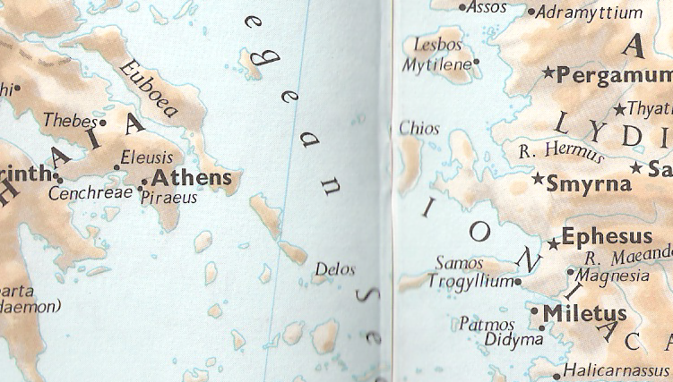

b. Ephesus was bypassed at the beginning of the second missionary journey because the Holy Spirit prevented the missionaries from going into the Roman Province of Asia (Acts 16:6). “Ephesus was the capital of the province of Asia and the residence of the Roman governor. It was a city of great size and importance both commercially and culturally. It contained the greatest of the seven wonders of the world, the temple of Artemis Diana.” “(The temple of Artemis was built of purest marble, was 425 feet long and 220 feet wide with 127 columns 60 feet high. It was destroyed by the Goths in 262 A.D. “Ephesus was on the main shipping route from Rome to the east. It was a free Greek city, with its own senate and civic assembly. There was a large settlement of Jews at Ephesus. The privileges granted them in 44 B.C. by one of the two consuls of Rome (Dolabella, a partisan of Julius Caesar). The privileges given to the Jews in Ephesus were later confirmed by Emperor Augustus.”
c. Paul had never been to Ephesus before, but he leaves Priscilla and Aquila there to continue to teach the new converts that are about to be made. Paul is credited with beginning the church in Ephesus, and this statement is where that church begins. It is hard to imagine Priscilla and Aquila sitting idle for several weeks or months while Paul went on to Jerusalem and then up to Antioch and eventually back to Ephesus. This missionary couple would have been evangelizing unbelievers and teaching new believers as they had done in Rome and Corinth and building on Paul’s foundation. Much credit for the success of the church in Ephesus goes to Priscilla and Aquila.
c. There is another theory put forward by scholars: “We know that they were at Ephesus (Acts 18:19) but we hear nothing of them after Paul’s arrival there (Acts 19:1), and since they are apparently in Rome when Paul writes to that church it is reasonable to suppose that they moved on from Ephesus before Paul arrived there.” This theory is based upon Paul’s greeting in Rom 16:3, “Greet Prisca and Aquila, fellow-workers with me in Christ Jesus.” Paul’s return to Ephesus was probably sometime in 53-54 A.D. Romans is written between 55-57 A.D. while Paul spends three years in Ephesus. So sometime either before Paul returned to Ephesus or after he had been there for a while, Priscilla and Aquila went back to their original home in Rome. This would certainly have to be after the death of Claudius, who expelled the Jews from Rome (Acts 18:2) in 49 A.D. and died in 54 A.D. It is most likely that Aquila and Priscilla stayed in Ephesus until Paul returned, and shortly after his arrival returned to Rome.

2. “Now after entering into the synagogue, he conversed with the Jews.”
a. Paul follows his normal practice of going to the Jewish synagogue, when he first arrives at a new city. He takes the message of the gospel to the Jews first.
b. Paul does the same thing mentioned previously by Luke in:
(1) Acts 9:22, “Now Saul kept on being strengthened even more and kept on confounding the Jews who lived in Damascus, by proving that This One is the Christ.”
(2) Acts 13:5, “And after they were in Salamis, they began to proclaim the word of God in the synagogues of the Jews. Now they also had John as a helper.”
(3) Acts 14:1, “Now it came to pass in Iconium that in the same way they entered into the synagogue of the Jews, and spoke in such a manner that a large number of both Jews and Greeks believed.”
(4) Acts 17:1-3, “Now after traveling through Amphipolis and Apollonia, they came to Thessalonica, where there was a synagogue of the Jews. Then according to Paul’s custom, he went to them, and for three Sabbaths conversed with them from the Scriptures, explaining and demonstrating that the Messiah had to suffer and rise up from the dead, and [saying,] ‘This Jesus whom I am proclaiming to you is the Messiah.’”
(5) Acts 17:10, “Then the brethren immediately sent Paul and Silas away during the night to Berea, who, after arriving, went into the synagogue of the Jews.”
(6) Acts 17:17, “Therefore he kept conversing in the synagogue [in Athens] with the Jews and the God-fearers, and in the market place every day with those who happened to be present.”
(7) Acts 18:5, “Now when Silas and Timothy came down from Macedonia, Paul began to be absorbed in the Christian message, testifying to the Jews [in Corinth] that Jesus is the Christ.”

Arndt, W., Danker, F. W., & Bauer, W. (2000). A Greek-English Lexicon of the New Testament and other early Christian literature. (3rd ed.) (p. 523). Chicago: University of Chicago Press.
Arndt, W., Danker, F. W., & Bauer, W. (2000). A Greek-English Lexicon of the New Testament and other early Christian literature. (3rd ed.) (p. 154). Chicago: University of Chicago Press.
Arndt, W., Danker, F. W., & Bauer, W. (2000). A Greek-English Lexicon of the New Testament and other early Christian literature. (3rd ed.) (p. 232). Chicago: University of Chicago Press.
Barrett, ICC, Vol 2, p. 878.
Bruce, p. 355f.
Guthrie, D. (1996, c1990). New Testament Introduction. (4th rev. ed.). The master reference collection (p. 492). Downers Grove, Ill.: Inter-Varsity Press.

