FORWARD
The Greeks loved to use ellipsis, which is the deliberate omission of a word that was so obvious from the context that is didn’t need to be written. For example, in the phrase “God is love” the writer could write “God love” and his readers knew that the verb EIMI, meaning “to be = is” was deliberately omitted. Therefore, when doing my translation I put an ellipsis in brackets “God [is] love” to indicate that the word in brackets is an ellipsis, a deliberate omission according to typical Greek writing style.
A similar problem exists with the direct object, which is also deliberately omitted, when it is so obvious from the context. This is especially true in the book of Matthew. He loved omitting direct objects that were obvious. An example can be seen in Mt 1:18, “Now the birth of Jesus Christ was as follows: after His mother Mary had been engaged to Joseph, before they came together, she was found having [a fetus] in the womb by the agency of the Holy Spirit.” Another example is Mt 2:3, “However, King Herod, after hearing [this], was troubled and all Jerusalem with him,”
Another problem in translating is the synonymous meanings of a word. For example, the word HUPOMONĒ, which has the meanings “comfort” and “encouragement” (see 2 Cor 1:3-7) or KATAKRIMA (Rom 8:1), which means both “condemnation” and “judgment.” In the Greek’s mind a judgment automatically and always followed a condemnation. The two were inseparably united. Therefore, one-word translations miss the mark. The Greeks didn’t think in terms of one meaning, but both meanings. They saw their one Greek word as having two or three sides of the same coin (heads, tails, and rim). Therefore, it is necessary to indicate this in translation “comfort [encouragement].”
There are parenthetical statements in Greek and they are indicated by the normal (…) signs.
One of the most difficult problems in translation is dealing with the Greek conjunctions that introduce a sentence: KAI, DE, and GAR. GAR is the easiest word to deal with, since it is always introducing a cause or reason, and you have to decide from the context which idea is most correct or do you have a blending of both. KAI is often nothing more than the habit of the Hebrew writer (all the NT writers were Jews and fluent in Hebrew/Aramaic), who was so use to the Hebrew letter WAW, which begins most sentences, and means “And.” However, the Greek word KAI has many more nuances and meanings: Now, Then, And so, In fact, Also, etc. So the context has to be analyzed to determine what the writer probably had in mind. DE is also complicated, meaning “However, But (mild use of the adversative as compared to ALLA, which is a dogmatic and emphatic adversative use), Now, Then, and its common use as a switch-reference device, when changing from one speaker to another (as in a Greek drama, to indicate the change of speaker). So these little introductory conjunctions say much more than most translators assign to them.
Punctuation is also a problem, since the original manuscripts and style of writing at the time did not use punctuation and had no space between letters, words, sentences or paragraphs. So sometimes the decision has to be made between a: period or semicolon, a semicolon or comma, a comma or period, etc. Here is an example from Codex Sinaiticus so you can see the problem.
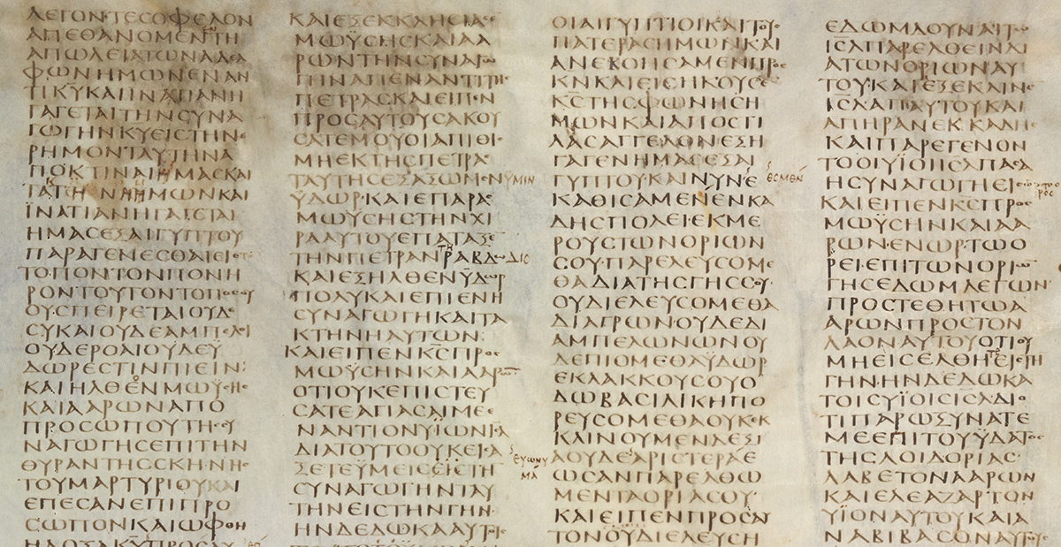

Another difficultly is the factor of time. I began this project in 1988 and completed it in 2020. Over the course of thirty-two years I learned much about Greek thinking, writing styles, differences in authors and their individual styles, favorite words, and how meanings of words changed over time. For example the preposition EPI meaning “on” came to take on the meaning “in” (the preposition EN) as Greek developed between 35 A.D. and 95 A.D. This is why we have translations such as “believe on the Lord Jesus Christ” and “believe in the Lord Jesus Christ” but the same or different prepositions are in common use at different times.
Therefore, based on all these difficulties, you might see lots of differences between my translation and other translations. You will find my translation most closely follows the New American Standard Bible (NASB), since I graduated from there in 1984, when the professors from there who wrote the NASB were still there as my professors. Though taught by them, my translation is my own, and all the mistakes you might find in it I take full responsibility for.

